Manual Testing

Table of Content: Page NO.

Module 1: Testing Fundamentals

1.1 Introduction to Software Testing
- What is testing?
- When do defects arise?
- Cost of Defect Repair
- Why is Software Testing?
- Objective of testing
- Advantages of testing
1.2 Introduction to SDLC
- SDLC Workflow
1.3 Testing Techniques
- Static Testing
- Dynamic Testing
1.4 Testing Methodologies
- White Box Testing
- Black Box Testing
- Grey Box Testing
1.5 Testing Levels
- Unit Level Testing
- Integration Level Testing
  - Incremental Integration Testing
    - Top-Down testing
    - Bottom-Up testing
  - Non-Incremental Integration Testing
    - Big bang Method
- System level Testing
- User Acceptance Testing (UAT)
  - Alpha Testing
  - Beta Testing
1.6 Testing types
- Smoke testing
- Sanity testing
- Usability Testing
- User Interface (GUI) Testing
- Functional Testing
- Re-testing
- Regression Testing
- Database Testing
- Compatibility Testing
- Ad-hoc Testing
- Exploratory Testing
- Security Testing
- Recovery Testing
- Installation/ Uninstallation Testing

- Performance Testing
  - Load Testing
  - Stress Testing
  - Volume Testing
  - Soak Testing
1.7 SDLC Models
- Water-Fall Model
- Incremental Model
- Prototype Model
- Spiral Model
- Rapid Development Model
- V Model
- Agile Model

Module 2: Process

2.1 Software Engineering
2.2 Project Management Process
2.3 Customer Satisfaction Survey
2.4 Change Management Process
2.5 Software Configuration Management:
2.6 Process Models & CMMI Levels
2.7 Verification (SQA) & Validation (SQC)
2.8 Testing Roles & Responsibilities

Module 3: Project

3.1 Project Management Plan
3.2 Requirement Documents
- Business Requirement Specs
- System Requirement Specs
- Functional Requirement Specs
3.3 Introduction to Software Testing Life Cycle
3.4 Stages of STLC
- Requirement Analysis
- Test plan preparation
- Test case preparation
- Prepare RTM
- Test Execution
- Defect tracking
- Test execution report
3.5 Introduction to Test Plan
- Contents of Test Plan:
  - Objective
  - Scope
  - Testing Environment
  - Deliverables
  - Roles and Responsibilities
  - Assumptions
  - Risks
  - Contingency plan
  - Approach
  - Effort Estimation
  - Schedule
  - Testing Methodologies
  - Defect Tracking
  - Entry and Exit Criteria
  - Test Automation
  - Templates
3.6 Example for Real Time Test Plan
3.7 Test Design
- Test Scenarios
- Test Cases
  - Process of authoring test cases
  - Model of Test Case Template
  - Contents of Test Case
  - Review Test Case
  - Characteristics of Good Test Case’s
  - Test Case Design Techniques
- Boundary value Analysis
- Equivalent Partitioning
- Decision Table
- State transition Testing
- Cause effect graphing
- Error guessing
3.10 Real Time Check List for Testing Life Cycle
3.11 Best Practices to be followed during Testing
3.12 Web Testing
- Functionality
- Usability
- User Interface
- Compatibility
- Security
- Performance
- Sever log file Testing
3.13 Projects & Technologies
3.14 Types of Architecture
- 1 - Tier
- 2 - Tier
- 3 - Tier
- N - Tier
3.15 Model View Controller Architecture

Module 4: Project Testing

4.1 Build from Development to Testing
4.2 Build Release Management
4.3 Defect Management
4.4 Defect Life Cycle
4.5 Defect Report Template
4.6 Contents of Defect Report
4.7 Defects in Java Web Application
4.8 Over View of Testing Process

Module 1: Testing Fundamentals

1.1 Introduction to SDLC
- SDLC (Software Development Life Cycle)/Project Life Cycle: All of the stages from start to finish that take place when developing new Software.

Phases of SDLC
Requirements

gathering

Design
Coding
Analysis

Testing
Release & Maintenance

SDLC Workflow

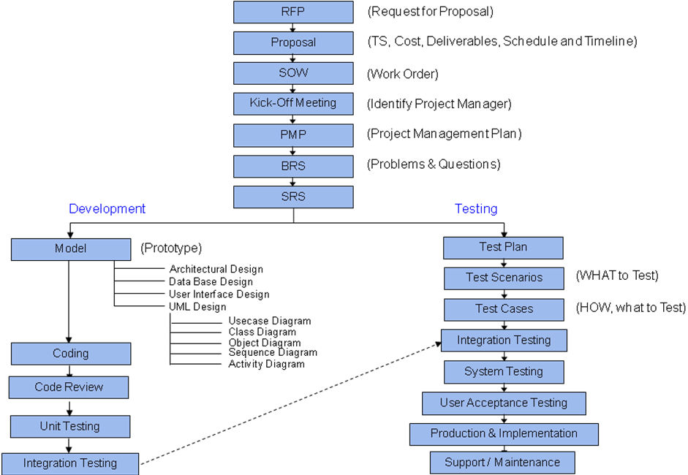

Request for Proposal [RFP]:

- Client will distribute the RFP to vendors (Software companies)
- Companies will respond to RFP with their proposals.

Proposal:
- Proposal contains Technical Solutions, Cost, Delivery, Schedule, Timeline, Deliverables…etc]

Feasibility Analysis:
  - Technical Feasibility
  - Schedule Feasibility
  - Financial Feasibility

Project Charter:

SOW (Statement of Work):
- Once the proposal gets confirmed by the client, they release SOW to the Company. SOW is a mutual agreement between the Client and Company, which consists of the Schedule and Financial details.

Kick-Off Meeting:

A Kick-Off meeting is the first meeting with the project team and the client of the project.

This meeting would follow definition of the base elements for the project and other project planning activities. This meeting introduces the members of the project team and the client and provides the opportunity to discuss the role of team member along with other key elements.

Key elements of this meeting –

  - Establishing Vision and Deliverables of the Project
  - Process to be followed
  - In-Scope and Out of Scope items
  - Identifying team and their responsibilities
  - Schedules of the project
  - Status Reporting
  - Tools to be used

Participants in Kick-Off Meeting – Client, Senior Management Team, Project Management Team, Business Analysts, Development Team and Testing Team.

PMP (Project Management Plan):

- Project Manager prepares PMP. The purpose of PMP document is to provide a comprehensive baseline of what has to be achieved by the project, how it is to be achieved, who will be involved, how it will be reported and measured and how information will be communicated.

Important contents of PMP –

- Project scope
- Project schedule and milestones
- Human resource requirements
- Software/Hardware requirements
- Budget/cost estimate
- Change Management
- Communication Management
- Risk Management
- Project issues

Business Requirement Specifications (BRS) –
Brief information about all the high level requirements of the project are called as Business Requirement Specifications. Business Analysts capture these requirements from Client.

Business Requirements Specification Document Contents –

- The purpose of the project
- The Client and Customer
- Users of the product
- The scope of the work
- The scope of the product
- Features and Functionalities
- Usability and Humanity Requirements
- Performance Requirements

System Requirement Specifications (SRS) –

Detailed information about complete requirements of the project is called SRS.

Different sections present in SRS –

- Overview
- Scope
- Features
- User Characteristics
- Software Requirements
- Hardware Requirements
- Performance Requirements
- Use Cases

Functional Requirement Specifications –

Sometimes technical information in SRS can be confusing to the Client, so we maintain such technical information in a separate Functional Requirement Specification Document.

Use Case –

Use Case explains the step by step procedure of how a particular functionality of software is used by the end user. Use Case contains many sections like Objective, Actors, Precondition, Basic Flow, Alternate Flows, Exceptional Flow and Post Conditions.

1. Basic Flow explains a general usage of the functionality step by step
2. Alternate Flows explains additional activities an end user can perform
3. Exception Flows explains general error or information messages thrown by system

Wireframes or Mock-up –

A diagram which simulates the feel of the actual screen is known as wireframe or Mock-up.

Qualities/Characteristics of a good requirement –

- Simple, concise, clear and complete
- Testable or Verifiable
- Unambiguous
- Independent
- Feasible (realistic and possible)
Design –
Design is the process of identifying the approach for implementation.
Based on approved SRS software Architect or Technical Lead will design the model of the project (prototype or blue print)

Design Types -
- User Interface Design (Designing the screens)
- Database Design (Designing the tables)
- Application Design (Designing the programs)
- High Level Design (HLD)
- Low Level Design (LLD)
User Interface Design –
Static screens are developed as part of UI design. UI design gives high priority because Client will have to review the UI of the application. It is developed by developers or UI specialists.
Database Design –
In the application if any data needs to be maintained, we will be using database packages like Oracle, SQL Server etc.
The data is saved in the form of tables with rows and columns.
When database is designed we aim at eliminating redundant data and this will be achieved using Rational Data Base Management System (RDBMS).
Application Design –
The programmatic implementation approach is identified as part of application design. Application design is implemented in two phases –
- High Level Design (HLD)
- Low Level Design (LLD)
High Level Design – It is also called as Architectural Design.
Architecture – The distribution of application is called as architecture.
Possible Architectures –
- 1 Tier
- 2 Tier
- 3 Tier
- N Tier
1 Tier –
Example – Notepad

UI Application
Acting as one element

2 Tier –
Example – Billing Package
UI Application
Visual Basic

Database
MS Access

3 Tier –
Example – Online Banking
UI
IE, Chrome, Firefox

Application
Web logic Server

Database
SQL Server

In High Level Design we identify the architecture to be followed for the current Project.
In High Level Design we also carry out Modularization of the application.
Client Server and Web-based Application –
Client-Server | Web Application
Testing is performed on product installed in a local computer | Testing is performed on content flowed from a webserver using a browser
2-tier architecture | n-tier architecture
The number of Clients is known | The number of clients is difficult to predict
Designed and implemented on intranet environment | Designed and implemented on internet environment

Modularization –
The process of splitting the application into small components in order to have easy implementation is called Modularization.

Project

M11
M21
M31
M41

Low Level Design –
It is called as detailed design. In LLD, we identify the implementation approach for all functionalities at every module level.
In Low Level Design the functional flow (or) program flow (or) data flow are identified and skeleton programs are developed.
Note –
- UI and DB designs may be optional for some projects, but application design will be mandatory.
Application Design is carried out by developers.

Coding –
Developers are going to convert the logics specified in design documents to programs as per chosen programming language.

Testing

What is testing?

- Validating whether the developed application is working fine as per the Client requirements or not.
- Testing is Executing a program with an intention of finding defects.
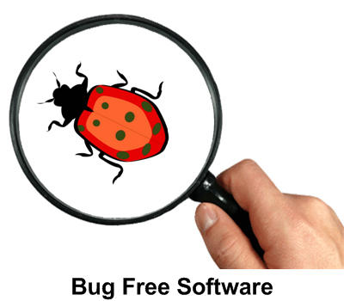
- Software testing is the verification process to know whether the Project is acceptable by its end users/customers or not.
- Identify differences between expected and actual results
- Testing includes inspection and structured peer reviews of requirements and design, as well as execution test of code.

Testing Objective –
Primary objective of software testing is to identify the defects in application and ensure Quality product is delivered to Clients.
Why does Software have Bugs?
- Poor coding standards.
- Unclear/misunderstanding about requirement specifications.
- Frequent changes requested by Client leads to bugs due to changes in design.
- Quantitative code is bound to have bugs.
- When project deadlines come too close and time pressure arises, mistakes are bound to come.

When do defects arise?

- Requirement 1: is implemented correctly - we understood the customer's requirement, designed correctly to meet that requirement, built correctly to meet the design, and so deliver that requirement with the right attributes: functionally, it does what it is supposed to do and it also has the right non-functional attributes, so it is fast enough, easy to understand and so on.

- Requirement 2: is fine until the software is coded, when we make some mistakes and introduce defects. Probably, these are easily spotted and corrected during testing, because we can see the product does not meet its design specification
- Requirement 3: we built exactly what we were told to but unfortunately the designer made some mistakes so there are defects in the design. Unless we check against the requirements definition, we will not spot those defects during testing. When we do notice them they will be hard to fix because design changes will be required.
- Requirement 4: Were introduced during the definition of the requirements; the product has been designed and built to meet that flawed requirements definition. If we test the product meets its requirements and design, it will pass its tests but may be rejected by the user or customer. Defects reported by the customer in acceptance test or live use can be very costly.
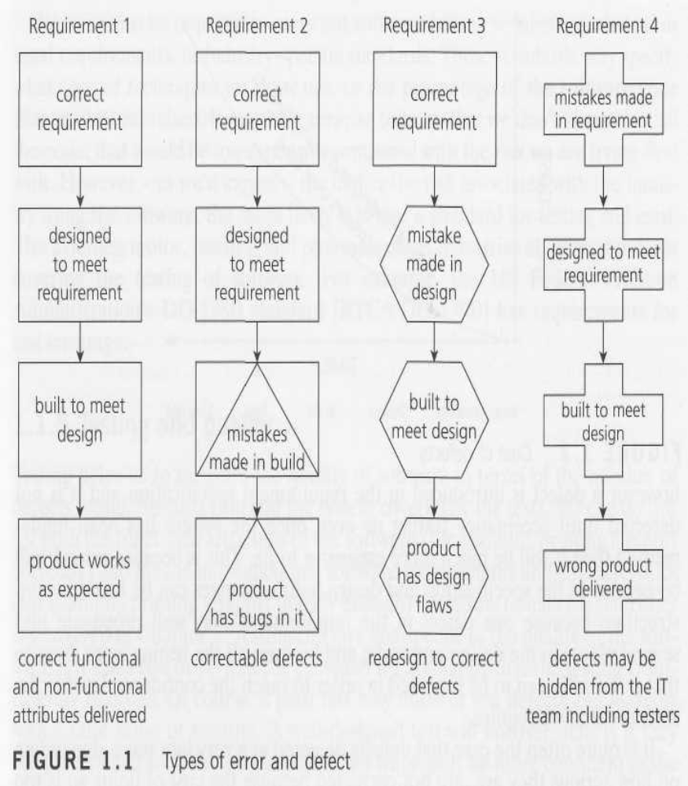

What is the cost of Defects?

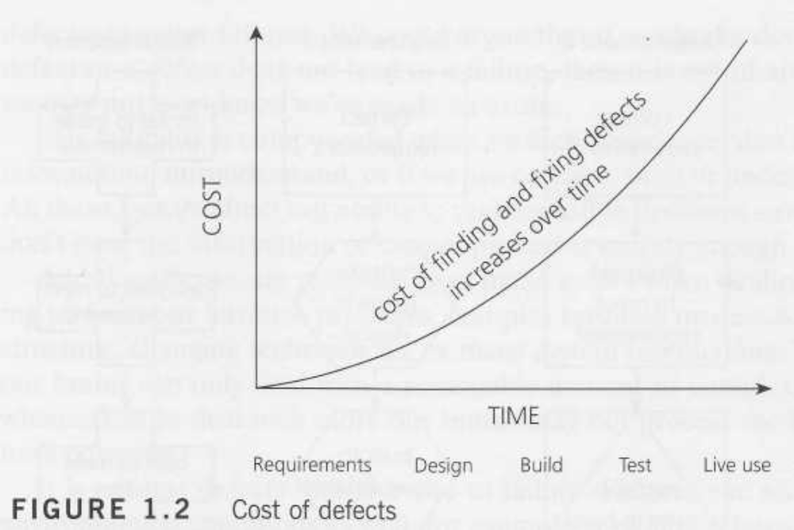

Example 1:
Phase | % Cost
Requirements | 0
Design | 10
Coding | 20
Testing | 50
Customer Site | 100

Importance of Software Testing -
Software testing is very important because of the following reasons:
- Software testing is really required to point out the defects that were made during the development phases.
- It’s essential since it makes sure of the Customer’s reliability and their satisfaction in the application.
- It is very important to ensure the Quality of the product. Quality product delivered to the customers helps in gaining their confidence.
- Testing is necessary in order to provide the facilities to the customers like the delivery of high quality product or software application which requires lower maintenance cost and hence results into more accurate, consistent and reliable results.
- Testing is required for an effective performance of software application or product.
- It’s important to ensure that the application should not result into any failures because it can be very expensive in the future or in the later stages of the development.
- It’s required to stay in the business.

Developers can do testing, Why Test Engineers are required? -

- Testers execute the application as an end user prospective, hence can find more bugs.
- Development and Testing are parallel activities, not Sequential. When a developer doing complete testing makes the activities sequential, this will increase the time to release the product.
- If requirements are misunderstood by developer then no matter at what depth developer test the application, they will never find the error.
- Some Optimistic Developers may think, since they wrote the code, they are confident that it’s working properly and assume no need to test and it’s working properly.
- Developer always wants to see their code working properly. So they will test it to check if it’s working correctly. But you know why tester will test the application? To make it fail in any way, and tester surely will test how application is not working correctly. This is the main difference in developer testing and tester testing.

Can you deliver bug free product with Testing? -
No one can guarantee bug free product through Testing. Testing helps to release a reasonably bug free product.
Objective of Software Tester
- The goal of software tester is To find bugs
- Find them as early as possible
- Make sure that they get fixed

Tester Qualities
- No compromise on the quality
- Negative thinking
- Analytical skills
- Patience
- Communication & Written Skills

Release –
The process of deploying the implemented and fully tested code to Production/Live environment is called “Release”.
Release process will be coordinated by a person called Release Manager, who gets approval from all management teams to go ahead with release.
Maintenance Phase –
Phase of a project after Production Release. This phase also called as Production Phase, Post Release Phase, Live environment and Customer environment.
Hot fix –
When a critical bug is identified in production environment that requires immediate fix else the business cannot continue. These kinds of issues are fixed and released immediately to customer. This is called hot fix.
Patch –
Patch is small software that contains fixes for one or more bugs identified in the application during maintenance phase.

Project and Product –
Project – Building the software for one Client/Customer is called as Project.
Example – IRCTC is a Indian Railways Project.
Product – Building one software for multiple Clients/Customers is called as Product.
Similar Product will be used by wide range of customers; it may require customizations according to their needs.
Example – Quick Test Professional (QTP) is a HP Product.

Building software for their internal business use is also called as Product.
Example – Wells Fargo, Bank of America, JP Morgan Chase.

SDLC Models

- Various SDLC models as below

- Water-Fall Model
- Incremental Model
- Prototype Model
- Spiral Model
- Rapid Development Model
- V Model
- Agile Mode

Waterfall Model /Sequential Model–
It is also referred to as a linear-sequential life cycle model. It is very simple to understand and use. In a waterfall model, each phase must be completed before the next phase can begin and there is no overlapping in the phases.
Following is a diagrammatic representation of different phases of waterfall model.
Requirements

Design
Coding
Testing
Release & Maintenance

Advantages –
- It is logical, Simple and easy to understand and use
- Phases are processed and completed one at a time.
- Clearly defined stages and well understood milestones.
Limitations –
- Cannot accommodate changing requirements.
- Not a good model for complex projects.
- Lack of involvement of the customer.
- Uneven loading of the resources.
- Last minute correction is difficult.
- Lot of Documentation is required.
- No working software is produced until late during life cycle.
- Not much time for testing and to fix defects.
- It does not support early catches, all bugs will be identified during testing phase, for which more rework may be required.
Note – Waterfall model is preferred when the requirements are very clear and implementation feasibility is known.

- Increment Model

  - Multiple development cycles take place here, making the life cycle a “multi-waterfall” cycle. Cycles are divided up into smaller, more easily managed iterations.
  - Each iteration passes through the requirements, design, implementation and testing phases.
  - A working version of software is produced during the first iteration, so you have working software early on during the software life cycle.
  - Subsequent iterations build on the initial software produced during the first iteration.

- Advantages:
  - Generates working software quickly and early during the software life cycle.
  - More flexible – less costly to change scope and requirements.
  - Easier to test and debug during a smaller iteration.
  - Easier to manage risk because risky pieces are identified and handled during its iteration.
  - Each iteration is an easily managed milestone.

Prototype Model – This is used when requirements are clear but implementation is not known. When implementation is not sure we try to develop a prototype of the application which will be a minimized version of the application with minimal set of requirements implemented. Depending upon the prototype results Client will decide whether to continue or not.
Note – Prototype development again follows Waterfall model

Requirement Collection

Requirement of Prototype
Testing and Evaluation Design

Coding

Design

Coding

Testing

Release and Maintenance
Advantages – We can test the feasibility easily
Limitations –
- Not a detailed Model
- Does not support dynamic requirements

- V Model

  - V-model is a software development model that is based on the relationships between each phase of the development life cycle as described in a typical Waterfall model of software development and its associated phase of testing.
  - The V-model gives equal weight to coding and testing in a software development process.
  - The idea of the V-model is to have a implementation plan for the software testing at each level namely component, interface, system, acceptance and release of the software project which need to be adhered to eliminate discrepancies in the software simultaneously rather than waiting for the software development process to complete before handling it to the software testing professionals.
  - The V-Model is a Software life cycle model.
  - It explains how you go from high level concept to released product.
  - At the top of the left V line, are the High level concepts.
  - At the bottom of the V is the coding phase.
  - At the top right V line is the released product.
  - The reason for calling it a V is because most of the phases on the left have a corresponding phase of activity on the right.

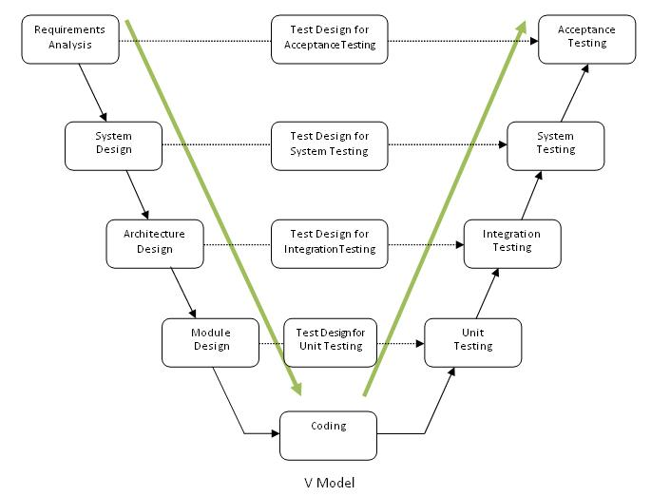

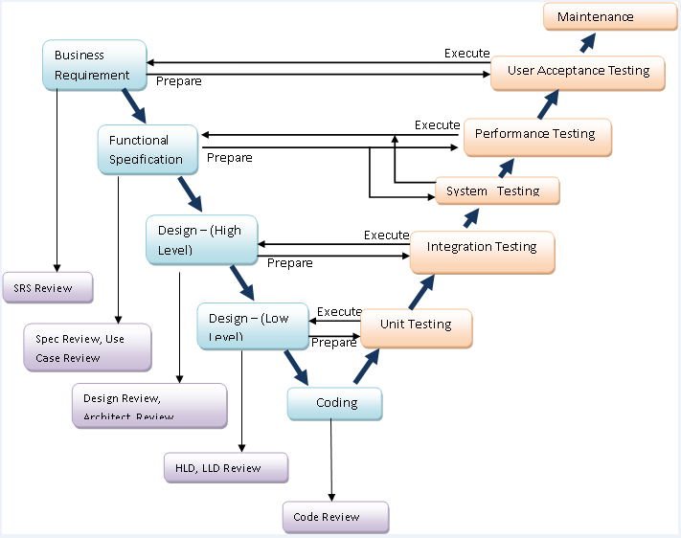

Verification and Validation –
Verification ensures “Are we building the right Product?” by using methods like Reviews, meetings, inspections, etc. It does not involve execution of code.
Example – Requirements review, Design Review, Test Cases Review, etc.
Validation ensures “Are we building the Product right?” validation is nothing but testing which involves execution of code.
Example – Execution of test cases.
Review, Walkthrough and Inspection –
Walkthrough - A walk through is an evaluation process which is an informal meeting, which does not require preparation.
Example – Review of documents within peers.
Review – A Review is an evaluation process which is a semi-formal meeting, which requires preparation. Reviewer comments/feedback is firmly documented and corrective measures are taken by the preparer. It may or may not require a moderator.
Example – Test case reviews by external teams.
Inspection – An Inspection is a formal evaluation process, which requires preparation. All the feedback points are firmly documented by the moderator and appropriate actions will be taken by the team after the meeting.
Example – Client Demo

Agile Model -

Agile Software Development Model –
Reasons why Agile Development Model– To overcome below challenges in sequential model we prefer to go for Agile.
- Ambiguous Requirements
- Requirement changes are inevitable.
- Big, upfront planning not practical.
- Reviewing the Working Software is better
- Iterative and Incremental development is better
- Delivery through small baby steps
- Frequent Reflections by Project Teams

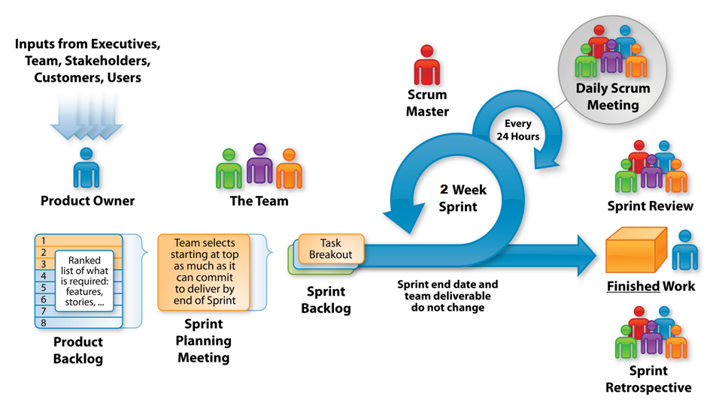
Scrum framework –
- What is Scrum?
- Scrum Roles
- Scrum Process in detail
Scrum – Scrum is a framework for developing complex products and systems. It is grounded in empirical process and control theory (inspect and adapt). Scrum employs an iterative and incremental approach to optimize predictability and control risk. – Ken Schwaber (One of the Founder of scrum)
Scrum Roles –
- Product Owner
- Scrum Master
- Scrum/Project team
Product Backlog Items (PBI) –
All the requirements/inputs from end users/Customers are listed together and called as Product Backlog Items. These PBI’s are priotorised by the Product Owner. This is a master list of features to be implemented. Product Owner is the only person who can make changes to PBI’s.
Backlog Grooming - The Product Backlog is constantly being revised by the Product Owner, to maximize the business success of the team’s efforts, this process is called as Backlog grooming.
Sprint – Sprint is one iteration (2-4 weeks) where team intakes PBI’s and implements the executable product by the end of sprint.
Working Software/Potentially shippable product should be delivered at the end of each sprint.
Sprint period is fixed and cannot be changed in middle. (Example – If we decided to go for 4 weeks sprint, then we should maintain the same till release of the product)
Sprint Backlog Items – The PBI’s which are considered to implement for a sprint are called as Sprint Backlog Items (SBI) for that respective Sprint.
Once the PBI’s are picked up for a sprint, no changes should be made to them; we need to wait till end of the sprint. If there are any such cases where there is a complete new high priotorized items to be accomplished, Product Owner will terminate the existing sprint and call for a new sprint with these items.
Sprint Planning Meeting – All items which are categorized for a sprint will be discussed during this meeting. Product Owner/BA’s explains the requirements to team and clarifies if they have any questions/ambiguities. Also the intake of the work for a sprint can be done by considering the available hours and actual hours required.
All the functional specifications/requirements are called as user stories. Points mentioned in each user story called as Story Points.
Scrum Team – Typically the scrum team should be 7-9 resources (Business Analysts, Developers and Testers).
Team breaks the SBI’s into tasks and be assigned to individual team members. (Test Case Writing, Test Execution, Regression Testing, etc.)
Burn Down – Individual team members have to burn the hours against the tasks assigned to them on daily basis, this gives the clarity of the on-going work and remaining hours left to accomplish the tasks. This will be evaluated by Sprint Burn Down charts.
Daily Scrum Meeting/Stand up Meeting – This is a short meeting where all team members will participate and let the entire team know –
- What is done for the day
- Plans for next day
- Any impediments/issues
Scrum Master – Scrum Master acts as a moderator/facilitator to the team. Primary responsibilities of Scrum Master –
- Notes down all the impediments of team.
- Resolve these issues for the team.
- Protect the team from external/internal disturbances
- Train the team, product owner on Agile process
Sprint Review Meeting – Product owner, team, scrum master and all other stakeholders are the participants of this meeting. There will be a demo of the working software to all of them during this meeting. This is a product review, where we take through all the items those were set for the sprint.
Sprint Retrospective Meeting – Product Owner, Team and Scrum Master are the participants of this meeting. This meeting will be conducted at the end of each sprint to capture below things –
- What went well
- What not went well
- Impediments and issues for which actions to be taken. The Improvement areas.
Velocity – Velocity is the key metric in Scrum. Velocity is calculated at the end of the Sprint by totalling the Points for all fully completed User Stories. Points from partially-completed or incomplete stories should not be counted in calculating velocity.
Example – There are 5 user stories as part of a sprint as below
User Stories | Story Points
1 | 10
2 | 5
3 | 6
4 | 5
5 | 6

Estimated Velocity – 32 Points
End of the Sprint –
User Stories | Story Points | Status
1 | 10 | Completed
2 | 5 | Completed
3 | 6 | Completed
4 | 5 | In-Progress
5 | 6 | Not Started

Actual Velocity – 21 Points
Overall Summary –
- It is an iterative, incremental framework
- Sprints – Cycles of work developed, duration is 2-4 weeks, occurs one after another without pause
- Time boxed – Sprints end whether or not the work ends
- At the beginning, team forms the priority list based on the customer requirements
- During the sprint the chosen items do not change
- Everyday inspection and adjustment
- End of the sprint, review with stake holders
- Feedbacks are taken and incorporated into the sprint
- End of sprint, fully tested product is formed as per customer requirements.

Software Testing Principles –
Software testing is based on certain principles that have evolved over the years. These principles guide testers and reduce software related problems.
There are seven principles of software testing. Some of these principles are referred to as general software testing principles, whereas others are referred to as applied software testing principles.
General software testing principles –
General software testing principles provide a standard framework to testers for conducting tests and discovering defects.
Testing Shows presence of defects – Principal One
Exhaustive testing is impossible – Principle Two
Confusing an absence of errors with product fit is a fallacy – Principle Three
Testing Shows presence of defects –
The first principle states that running tests on software will discover defects, but that the absence of defects does not mean that the software is defect free. These tests also decrease the possibility that the software still contains defects, but testing an application doesn’t mean that you will be able to remove all defects from the software.
Exhaustive testing is impossible –
Exhaustive testing is possible only when the Application under Test (AUT) is based on simple logic and requires minimal user input. But when the application uses complex logic and requires a lot of user input, it is impossible to conduct an exhaustive test on the application. So instead of testing every parameter, it becomes important to base your testing efforts on risks and priorities.
Confusing an absence of errors with product fit is a fallacy –
The fallacy states that although testing might succeed in locating and correcting all possible defects in the software, the software itself might not be fit for use by an end user. This might happen as a result of misinterpreting customer expectations, or as a result of poor usability.
Applied Software Testing Principles –
The applied principles of software testing concern the importance of early testing, defect clustering and pesticide paradox, and state that testing should always be context dependent.
Early Testing – Principle Four
Defect Clustering – Principle Five
Pesticide Paradox – Principle Six
Context Dependent – Principle Seven
Early Testing –
This principle states that testing should begin as early as possible in the Software Development Life Cycle.
If defects are detected during the initial stages of the SDLC, they can be corrected with minimum effort in terms of cost and time. Correcting defects during the initial stages prevents defects from cascading onto the development and implementation stages.
Defect Clustering –
This principle is based on the pretext that the defects aren’t spread uniformly in the software. During pre-release of the software, a few software modules will display the most number of defects and operational failures. This is referred to as Defect Clustering.
Pesticide Paradox –
This principle states that if you continue using the same set of tests over and over again, the tests will cease to uncover bugs. This can happen because during the testing, the software might have undergone changes. These new changes can no longer be checked using an old test case, so it becomes important to revise existing tests, and develop newer ones which will be able to uncover more bugs.
Context Dependent –
This principle states that you need to vary testing efforts depending on the circumstances.

Software Testing Life Cycle –
Below are the important phases in STLC -
Requirement Analysis
Test plan preparation
Test case Development
Test Execution
Result Analysis
Defect tracking
Test Status reports and QA Sign-off

Requirement Analysis –
Below are the important objectives of a tester during this phase –
- Analyze and understand the requirements.
- Clarifying questions/ambiguities with Business Analysts
- Identifying all possible Test Scenarios/Test Cases
Clarification Tracking –
We will be having a common clarification tracker (accessed by BA/PO, Dev & QA) in shared repository and all questions will be posted there for clarifications.
Whenever Dev or QA team have questions, we post them in clarification tracker and entire team will be notified with it.
Advantages of using common clarification tracker –
- Avoid duplicate questions to Business team.
- Ensure the process is followed and all the relevant artifacts are updated as per clarifications.
- Avoid individual interactions with Business teams.

Test Plan –
A Software Test Plan is a document describing the testing scope and activities. It is the basis for formally testing any software/product in a project.

It is a document which describes –
- What to Test
- When to Test
- How to Test
Test Plan Template –
- Title of the document
- Revision History
- Objective of the document
- Scope of the document
- Objective of the testing
- Brief description of the project
- Functionalities to be tested/not to be tested
- Types of Testing
- Test Environment
- Test Data requirements and collection
- Automation analysis
- Effort estimation
- Resource requirement
- Scheduling
- Training Requirements
- Input Criteria
- Exit Criteria
- Acceptance Criteria
- Test Suspension/Resumption Criteria
- Test Completion Criteria
- Test Deliverables
- Standards to be followed
- Risk Analysis
- Bug classification
- Bug Tracking
- Documents Referred

Title –
Test Plan of Project Name for Client Name
Revision History –
A table of information with different versions of the document and changes made against the each version.

Objective of the Document –
The Test Plan document documents and tracks the necessary information required to effectively define the approach to be used in the testing of the project.
Scope of the Document –
Objective of the testing –
- Testing is implemented in a project to make sure all client requirements are implemented.
- Ensuring testing is implemented within budget and time
- Testing can also be used for collecting data (metrics) which is helpful for future project planning.
Brief Description of the Project –
As test plan is the primary document in testing we maintain brief project information like users of the project, objective of the project, critical areas/modules of the project, architecture of the project etc.
Functionalities to be tested/not to be tested –
In general the complete project requirements need to be tested by testing team except some exceptional cases. Hence, we maintain features to be tested/within scope and not to be tested/out of scope in this section.
Example – Third party application integration with our application.
Types of Testing – The levels and types of testing to be performed with their short descriptions mentioned in this section.
Example – Smoke Testing, Functional Testing, System Testing, Regression Testing, Security Testing, etc.
Test environment –
Software, hardware and network environmental details are maintained here. This information is captured from requirement documents.
Test Data requirement and collection –
Test data can be collected from requirements and by assumptions. But some areas of application will require data from client.
The data requirement from client is listed in this section.
Automation Analysis –
The scope of the automation for the project will be mentioned here.

Resource Requirement –
Different resources like Human resources, software resource and hardware resource are involved in the project. The required resource count is captured in this section.
Human resource requirement is dependent on effort estimation and schedules. Need to specify number of people required.
Software and Hardware resource requirements are dependent on testing environment. Software’s including number of licences, Hardware with required configuration with number of systems need to be specified in detailed.
Scheduling –
Considering the Project Plan as input we develop the schedules for individual test phases like test case documentation, module level testing, system testing, etc. Schedules in test plan should be matching with the schedule in project plan.
Training Requirements –
Depending upon the team skill sets different training requirements are identified like –
- Technical Training – Like tools, programming, environments, etc.
- Domain Training – About the business domains like Healthcare, mortgage, etc.
- Soft Skills Training – Communication and Documentation
Input Criteria –
The common inputs for testers are like requirement documents, design documents, application, etc.
If the input is unstable the same errors in the input will be inherited in the testers work also. Hence, to avoid this tester need to make sure they accept stable inputs. Input criteria contains the status of the inputs with which tester will accept the input.
Inputs are of two types –
- Documents
- Application
Input Criteria for Documents –
Reviewed and baseline documents are acceptable documents.
Input Criteria for Application –
Unit tested application along with build release notes and installation document is an acceptable input.
Unit Testing –
A quick testing performed by developers in development environment to make sure that the application is stable and ready for testing.
Release Notes –
Build release notes from development team to testing team consists of –
- What is the release (Module name, Release Id, etc.)
- Implemented features
- Unimplemented features (if any)
- Known bugs/issues to the developer
Installation Document –
A detailed document with step by step procedure of the installation is provided to the tester.
Exit Criteria –
The conditions define to make sure that test deliverables are stable. Exit criteria also define the conditions for ending any testing activities.
Acceptance Criteria –
The set of conditions for bugs in the application, performance of the application, release dates, etc.
Test Suspension/Resumption Criteria –
Test Suspension – The conditions for which the testing is suspended when any show stopper bugs are identified.
(When any bug is identified on a critical functionality upon which many other functionalities are dependent)
Test Resumption –
Suspended testing will be resumed when the bugs are fixed.
Test Completion Criteria –
Testing is said to be completed when –
- All test cases are executed and are passed, application meets the client requirements.
- When the available time and budget is completed
- Bug rate falls below certain level (acceptance level)
Note – In practical scenarios 100% test cases pass may not be possible. Hence, testing will be completed when a pre-defined percentage of test cases are passed.
Test Deliverables –
All the deliverables from the testing phase are documented.
- Test Plan
- Test Case Documents
- Test Execution Reports
- Bug Reports
- Release Notes
- Installation Documents
- Application
Standards to be followed –
All the standards defined at Organization/Project level to be followed by testing team.
Example – Templates, Test case writing standards, Defect logging standards, etc.
Risk Analysis –
What is risk?
A risk is a problem that is likely to occur and when it does occur, will cause impact on deliverables.
Identify all possible risks in testing phase and providing their mitigation plan.
Test Estimations –
The total amount of time required to accomplish the testing tasks will be identified as part of
Test estimations by using different techniques.
Major Testing activities are -
- Requirement Analysis
- Creating the test cases
- Test Execution
- Defect Reporting and closure
- Updating Regression Test Suite
Techniques –
- Test case Based Estimation
- Work Breakdown Structure (WBS)
We mostly go with Test Case Based Estimation –
Process –
- Identify all possible test cases for the given requirements for the cycle
- Categorize the test cases as High/Medium/Low depends on the complexity
- Once these numbers are provided, we will get the total hours
Requirement Details
Sl # | QA Components | Number of components |  |  |  | Remarks/ Assumptions
Sl # | QA Components | Simple | Medium |  | High | Remarks/ Assumptions
1 | Requirement1 | 4 | 1
2 | Requirement2 | 2 |  |  | 1
3 | Requirement3 | 8 | 4 |  | 1
 | Total Count | 14 | 5 |  | 2

Effort Estimate -
QA Components
Complexity | Simple | Average | Complex
Effort (Pdays) from Functional requirements till Testing | 0.25 | 0.5 | 0.75
Count | 3.5 | 2.5 | 1.5
Total Effort | 3.5 | 2.5 | 1.5 | 7.5
 | Total Effort (Pdays) |  |  | 7.5

Estimation Guidelines -
Estimation Guidelines
Simple
1. Defects which has 1-2 scenarios to test as part of defect verification. (For Warranties)
2. Requirements having one functionality to be covered and tested.
3. Requirements with less than or equal to three screens to be covered during testing.
4. Requirements which need to be tested with <= two different type of Data/Scenario.
Average
1. Defects which has 2-3 scenarios to retest as part of defect verification. (For Warranties)
2. Requirements having 2-3 functionalities to be covered and tested.
3. Requirements with 3-5 actions to be covered during testing.
4. Requirements which need to be tested with 3-4 different type of Data/Scenario.
Complex
1. Defects which has more than 3 scenarios to retest as part of defect verification. (For Warranties)
2. Requirements having more than 3 functionalities to be covered and tested.
3. Requirements with more than 5 screens to be covered during testing.
4. Requirements which need to be tested with more than 4 different type of Data/Scenario.

Test Strategy –
A Test Strategy defines “Software Testing Approach” to achieve testing objectives. The Test Strategy is normally derived from the Business Requirement Specification document.
This document is a high level document as part of Project Plan and normally developed by project /Test manager
Major Components of the Test Strategy document
- Scope and Objectives
- Roles and responsibilities
- Communication and status reporting
- Test deliverables
- Industry standards to follow
- Test automation and tools
- Testing measurements and metrics
- Risks and mitigation
- Defect reporting and tracking
- Change and configuration management
- Training plan
Test Case Development –
- Test Scenario Identification
- Developing Test Cases
- Test Data Management
- Test Cases Review
- Test Coverage
- Requirement Traceability Matrix (RTM)
- Using Testing Techniques

Test Scenario Identification –
A `Test scenario’ is the summary of a product’s functionality, i.e. what will be tested.
A ‘Test Scenario’ consists of one or more test cases in order to validate the product’s functionality.
Process of Identifying Test Scenarios –
- Understand the functional work flow and imagine possible users and usage scenario for the application.
- The scenarios should cover end-to-end functionality of the application and all the business flows of the application.
- The identified scenarios should be independent of other test scenarios.
- Ensure that every identified scenario is a functional point in itself.
- Test scenarios must cover the negative and out-of-the-box testing with a ‘Test to Break’ attitude.
- Domain knowledge is important to get a deeper understanding of the application.
- All the scenarios should be mapped with the requirements document/user stories of the application.
- Test scenarios should be reviewed by the Product Owner/Business Analyst or anyone else who understands the requirements really well.

Test Case –
A ‘Test Case’ is set of executable test steps, which is used to validate project functionalities.
The test case should contain a set of test data, preconditions, expected results and post conditions, developed for a particular test scenario in order to verify a specific requirement.
IEEE Test Case Definition: A set of inputs, execution pre-conditions & expected outcomes developed for a particular objective, such verify compliance with the specific requirement.

Entry Criteria to prepare test cases:

Approved Test Plan
Approved SRS
FRS & DD
Approved Test Scenarios
Test Case template

Exit Criteria for test cases:

Test Cases should be reviewed & approved.
We classify test cases based on testing element –
- User Interface (UI)
- Usability
- Functionality
- Validations
User Interface (UI) Test Cases –
These are used to validate the look and feel of the application.
Example – Alignment, Size, Shape, Font, Colour, Enable/Disable, Visible/Hidden, Active/Inactive, etc.
Usability Test Cases –
These are used to validate the user friendly behavior of the system (or) Easiness to use the application.
- Default cursor focus
- Tab order
- Default Submit Button
- Short Cut Keys
- Tool Tip
Functionality Test Cases –
Test cases are developed for all functional requirements.
Example – Saving the data, Clear the fields, Saving the duplicate data etc.

Validations –
These test cases are implemented to avoid invalid data processing in the system.
Here we use the black box testing techniques to write the test cases.

PROCESS OF WRITING TEST CASES -

Requirement Analysis

Prepare Test Scenarios

Prepare Test cases
Applying Test case - Design Techniques

Review Test cases

Fix the Review

Comments

Approval

Model of Test Case Template

Project name:
Module name:
Requirement Id:
Author:

Test Case Id | Test Case Name/Title | Pre-Conditions  Steps to Reproduce | Test Data | Expected Result | Testing Type | Review Status | Priority | Comments

Contents of Test Case:
Test case id/name: Describes the name of the test case according to the company standard. E.g.cbo_finance_001
Requirement Id: Describes for which requirement we prepared test case. E.g. 100.1
Project name: Describes the name of the project. Ex - Citibank Online
Module name: Describes the name of the module. E.g. Finance
Priority: Describes the test case impact of the module of the business. E.g. High/Medium/Low
Pre-condition: Describes the pre-conditions which are to be followed according to the requirements.
Test data: Describes the test data to be used while executing the test case. E.g. user name, password
Test case type: Describes the type of test case. E.g. Functional/Integration/System test case
Author: Describes the tester name who has written the test case.
Review Status: Describes whether the test case is reviewed or not.
Last modified date: Describes the date of last modification in the test case.

Guidelines for writing test cases –
- First understand the requirements & while writing test cases do not assume any requirements by your own.
- Prior to design the test cases figure out all features of application.
- Ensure that test case should cover all functionality mention in requirement document.
- Avoid repetition of test cases which help to get exact scope of testing.
- Testing Priority should be assigned to each test case. Select the Test case priority depending upon how important the test case is for that Feature, component or the product.
- Test cases should be grouped properly (Phase wise, Module wise, Sprint wise etc.), so that we can maintain good quality test cases.
- While writing test cases all test cases should be simple and easy to understand. Don’t write explanations like essays. Be to the point.
Characteristics of Good Test Case’s

A good test case satisfies the following criteria

- Simple, complete and easy to understand
- Unambiguous
- Independent
- No Duplicates
- Reusable
- Effective – Finds Faults (Objective)
- Evaluable – Easy to maintain
- Requirement Coverage
- Requirement Completeness
- Easy to understand
- Should not be out of scope - do not contain unnecessary things

Test Data Management –
Test Data for validating functional test cases can be available in two ways –
- User owned/provided test data
- Real time test data
User Test Data – For few cases end users are privileged to enter their own data in application and this flow within the system.
Real time test data – The test data collected in real time will be provided to testing teams in the form of excel sheets (Or) database, etc. for functionality validations.
Note – Most of the times we end up with Real time test data.

Test Case Review:

Once all test cases are prepared, they all should be reviewed, incorporated with the review comments and baseline.
Peer Review – Test cases prepared by one team member will be reviewed by other member of the team and vice versa.
Lead Review – After the peer reviews, Test Lead will have a final review of test cases to ensure that all functionalities pointed in requirements are covered in test cases and coverage is 100%.
Business Review – Testing team will walk through the test cases prepared for the release to the business team (Business Analysts, Product Owner, etc.). If there are any review comments, we will incorporate the same.
Test Case Review Guidelines –
- Identify all the test cases are written as per the test case writing guidelines provided in the project/client.
- Verify all the basic flows are covered in test cases.
- Verify all the alternate flows are covered in test cases.
- Verify the test data against the test cases is provided accurately.
- Verify the test steps are clear, complete and reproducible.
- Verify the Actual Results are correctly captured.
- Verify the ‘Comments’ section is updated when the test case is incomplete with reasons.
- Verify for the duplicates.

SAMPLE OF TEST CASE REVIEW TEMPLATE

Serial No. | Test case name | Step No. | Comments | Severity | Author
1 | CBO_Loan_IR | 5 | Test data is wrong | Major | Fixed

Test Coverage and Requirement Traceability Matrix (RTM) –
We can say the test coverage is 100% when all the project requirements are converted into test cases by –
- All Basic and alternate flows are covered
- All Positive and Negative test cases are covered.
We use Requirement Traceability Matrix (RTM) to check whether the test case coverage is complete or not.
Requirement Traceability Matrix (RTM) – Mapping all the test cases derived for a requirement will be mapped to check whether all possible test cases are covered for that requirement or not. We also use RTM for Defect mapping also.
Req. Id | Req. Description | Test Case ID | Test Case Description/Title | Defect ID | Defect Description/Title
Login 1.1 | Validating login | LO_TC_001  LO_TC_002  LO_TC_003  LO_TC_004 | Login with VU& VP  Login with VU& IP  Login with IU& VP  Login with IU& IP | D1245 | User is unable to login to application even when valid credentials are provided.

Testing Techniques/Methods –
White Box Testing –
It is also known as Glass Box Testing, Transparent Box Testing, Clear Box Testing and Structural Testing.
Testing the application using test cases that are developed from the code, White Box Testing examines the program structure and derives test data from the Program logic/code.
Coverage Techniques –
White box testing deals with internal logic, hence coding knowledge is required. Generally developers perform White box testing.
Example – Unit testing, Integration Testing
White box test cases are developed by using below coverage techniques –
- Statement Coverage
- Condition Coverage
- Path Coverage
- Branch Coverage
- Loop Coverage
- Data flow based testing
Statement Coverage – Test cases are developed so that every executable line of code is tested at least once.
Condition Coverage – Test cases are developed so that all possible conditions in the program are tested at least once.
Path Coverage – Test cases are developed so that all independent paths in the program flow are tested at least once.
We need to have flow diagrams in order to develop path coverage.
Branch Coverage – Test cases are developed so that all possible branches at the conditions are tested.
Loop coverage – Test cases are developed for all possible loops of the program.
In loop coverage the main focus will be on loop initiation and termination.
Data flow based testing – Test cases are developed to test the data flow within the programs and across the programs.
Data flow diagrams are required for developing test cases.

Black Box Testing –
Testing the application using the test cases that are developed from requirements and design information.
It is carried out without the knowledge of internal implementation. It is also called as functionality testing.
Black box tester will not have access to the code or internal functionality.
The objective of Black box testing is to check the correctness of functionality with the help of input and output data.
Black Box Testing Techniques –
- Boundary Value Analysis (BVA)
- Equivalence Class Partition (ECP)
- State Transition Testing
- Decision Table Testing
- Error Guessing
Boundary Value Analysis (BVA) –
This testing technique is applied for the numeric requirements. If the input field is a non-numeric type, BVA can be applied on the size of the input.
Domain – The set of acceptable inputs of an input field is called domain.
BVA Process –
- Consider the limits of the domain as boundaries
- Identify the adjacent values of the boundaries
- Identify intermediate boundaries within the domain (Intermediate boundaries are the values within the domain for which application behavior changes. Intermediate boundaries may or may not be available within the domain).
- Identify the adjacent values for the intermediate boundaries.
- Test the functionality with boundary and their adjacent values.
Example – Marks System
1-100 = Domain
1-34 = Failed
35-49 = Passed with Third Class
50-59 = Passed with Second Class
60-74 = Passed with First Class
75 and above = Passed with Distinction
Values to be validated – 0,1,2,34,35,36,49,50,51,59,60,61,74,75,76,99,100,101
Equivalence Class Partitioning (ECP) –
Equivalence class partitioning (ECP) is a software testing technique that divides the input data of a software unit into partitions of equivalent data from which test cases can be derived.
ECP Process –
- Identify the range where samples need to be picked
- Identify the required number of samples (n)
- Partition the range to “n” equal intervals
- Pick the samples at the partitions
Example – Collect 3 samples in the range in between 10,000 to 20,000
- Range is 10000 -20000
- Number of samples required is 3
- Partitions 10000, 12500, 15000, 17500, 20000
Values to be validated – 9999,10000,10001,12499,12500,12501,14999,15000,15001,17499,17500,17501,19999,20000,20001
State Transition Testing –
State Transition Testing is a technique in which test cases are designed to test the application trigger from one state to another. To design test cases, identify all the states of the system and ensure that all states are covered from start to finish.
Example – A System's transition is represented as shown in the below diagram:

OFF

ON
FAULT

The tests are derived from the above state and transition and below are the possible scenarios that need to be tested.
Tests | Test 1 | Test 2 | Test 3
Start State | Off | On | On
Input | Switch ON | Switch Off | Switch off
Output | Light ON | Light Off | Fault
Finish State | ON | OFF | On

Decision Table Testing –
Decision Table Testing is a good way to deal with business logic where multiple conditions are used to take decisions.
Example – Login of an application
Requirement – Login button should be enabled only when user enters values in both ‘Username’ and ‘Password’ fields.
Username
Login
Password

Conditions | Rule1 | Rule2 | Rule3 | Rule4
Username | F | F | T | T
Password | F | T | F | T
Login | F | F | F | T
Outcome | F | F | F | T

Error Guessing –
Based on the previous experience and understanding of the current application, tester will guess the errors and write the test cases for the same.
The success of error guessing is very much dependent on the skill of the tester, as good testers know where the defects are most likely to be.
Grey/Gray box testing –
Grey Box Testing is a software testing method which is a combination of Black Box Testing method and White Box Testing method.
In Black Box Testing, the internal structure of the item being tested is unknown to the tester and in White Box Testing the internal structure in known.
In Gray Box Testing, the internal structure is partially known. This involves having access to internal data structures and algorithms for purposes of designing the test cases, but testing at the user, or black-box level.
Types of Testing –
Unit Testing/Component Testing –
Unit testing is a level of software testing where individual units/ components of software are tested. The purpose is to validate that each unit of the software performs as designed.
A unit is the smallest testable part of software. It usually has one or a few inputs and usually a single output. In procedural programming a unit may be an individual program, function, procedure, etc. In object-oriented programming, the smallest unit is a method, which may belong to a base/ super class, abstract class.
Benefits –
- If good unit tests are written and if they are run every time any code is changed, we will be able to promptly catch any defects introduced due to the change.
- The cost of fixing a defect detected during unit testing is lesser in comparison to that of defects detected at higher levels.
Unit testing is carried out by developers in their environment once the code is completely developed for the given requirements.
Integration Testing –
Integration Testing is a level of software testing where individual units are combined and tested as a group.
Integration is carried out in two ways -
- Classical Integration
- Incremental Integration
Classical Integration –
For a high level Unit if there are more than two low level units the process of integrating all low level units together in a single phase to get the high level unit is called as Classical Integration.
Advantage – Integration is implemented in a single phase.
Limitation – Integration testing may be complex when the dependencies are more.
Incremental Integration –
When there are more than two low level units for a high level unit the process of integrating the low level units’ one with other at a phase is called Incremental Integration. In this model high level module will be available after multiple phases of the integration depending on the number of low level units.
Advantage – The process is simple.
Limitation – Time requirements are more.
Note – Classical Integration is implemented at sub module level and incremental integration is implemented at module levels.
Integration test strategies –
- Bottom-up Integration
- Top-down Integration
- Big-Bang Integration
Bottom-up Integration –
It is an incremental integration testing technique which begins by developing and testing the Bottom level modules first and progressively adding and testing Top level modules one by one.
Any bug during high level integration testing does not require analysis of low level units, since they are already stabilized.
Top level modules are normally simulated by Drivers.
Driver – Driver is the code which calls other functions. Driver checks whether the function developed is correctly working or not based on the return value.
Top-down Integration –
It is an incremental integration testing technique which begins by developing and testing the top level modules first and progressively adding and testing lower level modules one by one.
Lower level modules are normally simulated by Stubs.
Stub – It is a prototype of a function. Prototype means, only the skeleton of the function without any code.
Limitation – A bug at high level integration may require analysis at high level units as well as low level units.
Note – Bottom-up Integration testing will be the preferred model in general.
Different Types of Integration testing –
- Component Integration testing
- System Integration Testing
Component Integration Testing –
It is conducted to test whether the data flow between two or more components is happening properly. For example checking data transfer between Registration and Login components.
System Integration Testing –
It is conducted to test whether the data flow between two or more systems is happening properly.
For example checking the data transfer between IRCTC and ICICI Net banking is happening properly. Here IRCTC is one system and ICICI Net Banking is the other system.

Static and Dynamic Testing –
Testing the project without executing the software is called as Static Testing.
The errors in the application are found by checking the syntax or reading the code manually, hence it is also called “Dry Run Testing”.

Example – Review of various documents like Requirements, Design documents and identify mistakes in these documents. Mistakes identified during this review are defects in the work product and this will reduce the cost to fix.
Testing the project by executing the software i.e. by running the application and going through the screens is called Dynamic Testing.
In Project we need to have both Static and Dynamic Testing.
Positive and Negative Testing -
Test to “Pass” is Positive Testing and test to “Fail” is negative testing.
Positive testing can be performed on the system by providing the valid data as input and checks whether application behaves as expected with positive input, which it supposed to do.
Example – User should login to the system with a valid username and password,
Negative testing can be performed on the system by providing the invalid data as input and checks whether application behaves as expected with negative input, which it supposed to do.
Example – When user enters Invalid Username and password and tries to login system, an error message should be displayed,
System Testing –
System Testing is defined as the process of testing an entire system to verify that it meets specified requirements.
System Testing is of two types –
- Functional System Testing
- Non-functional System Testing
Functional System testing – It is nothing but testing the system based on its functional behavior.
Non-functional System Testing – It is nothing but testing the system based on all other aspects except its functional behavior.
Smoke/Sanity Testing/Build Verification Testing –
Whenever a build get deploys from the development team, testing team perform a quick testing by navigating through all pages to ensure all the major functionalities are working fine and build is stable and ready for detailed testing.
If this testing is passed, we will continue with the detailed testing.
If this testing is failed, we reject the build because the application is not ready for detailed testing.
Smoke or Sanity testing is same. In some organizations/projects they may use Smoke or Sanity testing.
GUI Testing – Verifying the User Interface of the application means how the front end design, font, color, Text format, Label, Background etc.
This is the process of verifying the look and feel environment of the application.
Usability Testing –
User friendly behavior of the system (Or) easiness to use the application.
- Default Cursor Focus
- Tab Order
- Default Submit Button
- Shortcut Keys
- Tool Tip
Default Cursor Focus – The first input field of the form should have the cursor focus by default.
Tab Order – Tab should be implemented in the form and movement should be in input fields only. Tab order should be left to right in downward direction.
Tab Order – Tab should be implemented in the form and the movement should be in input fields only. Tab Order should be Left to Right in downward direction.
Default Submit Button – When the cursor focus is in any editable input fields on click of enter key a button with positive action should be triggered.
Short Cut Keys – For all buttons, menus, short cut keys should be implemented using Alt/Ctrl/Shift + Short cut key character.
Tool Tip – The additional online help is displayed when we mouse hover.
Functionality Testing – Testing all the functionalities mentioned in requirements is called as functionality testing.
End to End Testing –
End-to-end testing is used to test whether the flow of an application right from start to finish is behaving as expected. The purpose of performing end-to-end testing is to identify system dependencies and to ensure that the data integrity is maintained between various system components and systems.
The entire application is tested for critical functionalities such as communicating with the other systems, interfaces, database, network, and other applications.
Example – Right from logging into IRCTC application till ticket booked.
Retesting –
After a bug fix is implemented, we need to test the bugs again to ensure they are fixed properly, this is called Retesting.
Testing same functionality again and again with multiple sets of data is also called as Retesting.
Regression Testing –
Apart from testing bug fixes, we need to test the dependencies and basic work flow of the application to ensure they are not impacted during the bug fixing process, this is called Regression Testing.
Regression testing is implemented at every phase of testing.
Retesting and Regression testing will be implemented as a single phase.
Ad-hoc testing –
Ad-hoc testing is an informal testing type with an aim to break the system. This testing is usually an unplanned activity. It does not follow any test design techniques to create test cases.
This testing is primarily performed if the knowledge of testers in the system under test is very high. Testers randomly test the application without any test cases or any business requirement document.
Exploratory Testing –
Testers have to understand the application first by exploring the application and based on this understand they should come up with the test scenarios. After that start actual testing of application.
Testers will be having very minimal knowledge on requirements/application.
Exploratory testing is generally implemented when there are no or very minimal documentation available.
Risk Based Testing –
When testing team does not have enough time to accomplish the execution due to any reasons (mostly when there are deployment delays), we go with this approach.
- Execute all the test cases with High Priority first.
- If time permits, continue executing Medium and Low Priority test cases next.
Note – Ensure the test cases are priotorized during writing phase by considering Risk Exposure Factor for each test case.
Database Testing –
Validating the structure of Database and ensuring the data flow from Database to User interface (UI) and vice versa.
Database testing basically include the following.
- Data validity testing.
- Data Integrity testing
- Performance related to data base.
- Testing of Stored Procedure, Triggers, Views and functions.
Application Programming Interface (API) Testing –
API stands for Application Programming Interface. It enables communication and data exchange between two software systems. A software system implementing an API contains functions which can be executed by another software system.
Example – Withdrawing cash from an ATM which is different from the person holds. Withdrawing money in SBI ATM using ICICI bank card.
Parallel Testing –
Testing different versions of the application (old and new) by providing the same data and comparing the results is called parallel testing.
Compatibility Testing –
Compatibility testing is a type of software testing used to ensure compatibility of the system/application/website built with various other objects such as other web browsers, hardware platforms, etc.
Browser Compatibility Testing –
Below is the procedure you can follow for Browser Compatibility Testing –
- Identify all the browsers you wish to test (IE, Firefox, Chrome, Safari, etc)
- Create a compatibility matrix for above browsers
- Run your tests on all browsers
Security Testing –
Security testing is basically a type of software testing that’s done to check whether the application or the product is secured or not.
It checks to see if the application is vulnerable to attacks, if anyone hack the system or login to the application without any authorization.
6 Basic principles of Security testing –
- Confidentiality
- Integrity
- Authorization
- Authentication
- Availability
- Non-Repudiation
Localization and Internationalization Testing –
Internationalization Testing – It is the process of testing whether the software application can be adapted to various languages and regions. This is also called as I18N (I-EIGHTEEN-N) testing since there are 18 characters in between I and N.
Localization testing – It is the process of testing whether the software has been adapted correctly for a specific language. This is also called as L10N (L-TEN-N) testing since there are 10 characters between L and N.
Globalization Testing – Some companies use the term Globalization for the combination of Internationalization and Localization. Globalization can also be abbreviated to G11N.
Recovery Testing -
Recovery testing is done in order to check how fast and better the application can recover after it has gone through any type of crash or hardware failure etc.
Recovery testing is the forced failure of the software in a variety of ways to verify that recovery is properly performed.
Example – Multiple sessions in a browser
Performance Testing –
Testing the performance of an application under various working conditions, it is implemented only after system is stable.
Parameters of Performance Testing –
- Response time
- Execution time
- Through put
- Server resource utilization
- Network performance
Response Time – The time from request to the time when the first bit of response is received.
Example – When you open a web page after 2 seconds you see the frames of the page, hence 2 seconds is the response time.
Execution Time – The time from request to the time when we get complete response.
Example – When you open a web page you will see complete page after 6 seconds, hence 6 seconds is execution time.
Through Put – The amount of work done per unit time, like number of requests processed in one second or the amount of data transferred in one second.
Server Resource Utilization - There are two critical resources at server end –
- Processor
- Memory
Processor – When poor performance is identified to analyse the processor influence on the performance, we study the processor utilization during application usage.
While using the application if processor usage is identified as high, we can go with upgraded processor for improving the performance.
Memory – While analysing memory we study the memory swap-age count, if the memory swap-age count is high it is the indication for low memory resource at the server.
So memory upgrading will provide the better performance of the application.
Data Volume Testing –
Volume testing refers to testing a software application or the product with a certain amount of data. Example - if we want to volume test our application with a specific database size, we need to expand our database to that size and then test the application’s performance on it.
The purpose of volume testing is to determine system performance with increasing volumes of data in the database.
Multiuser Testing –
Testing the performance of an application for various numbers of concurrent users.
Network Performance – Network delays in the communication between client and server can influence the performance of the system.
We analyse network delays from server to client and client to server.
Load Testing –
Testing the performance of application for the conditions, which are within the requirements of the client.
Example – Client requirement is 500 users and testing carried out till 500 users.
Stress Testing –
Testing the performance of application for the conditions, which are beyond the requirements of client, is called Stress Testing.
Example – Client requirement is 500 users and testing carried out beyond 500 users.
Bottle Neck – The threshold stress point where there is a drastic performance fall is identified and it is called the Bottle Neck.
Acceptance Testing –
This is a test phase where all business critical requirements are retested by a different group of test members.
It is implemented at two phases –
- Alpha Testing
- Beta Testing
Alpha Testing – Testing performed by members of the organization that developed the software but who are not directly involved in the project (Development or Testing). Usually, it is the members of Product Management, Sales and/or Customer Support.
Beta Testing – Testing performed by the end users of the software in their environment. End users can be the customers themselves or the customers’ customers.
Test Execution –
Environments (Dev, Test, UAT and Prod) –
Dev Environment – Development Environment is where all the built code for current Cycle/Sprint requirements is deployed on the existing system available and accessible by developers for their testing purpose.
Sometimes testers also may test the application in Development Environment per requests and all bugs will be reported. These bugs will be fixed before the build deployed to QA environment.
Example URL – http://dev.gmail.com
QA Environment /SIT Environment/Test Environment– This is the environment where exactly the testing team works on and execute all the test cases. We will be maintaining two QA environments (QA1 & QA2) for production like environment and current on-going release environment.
QA1 – Production like environment (Build available in this environment is same like the build available in production).
http://QA1.gmail.com
QA2 – Current release items environment. All the on-going work for current release will be deployed on the existing system and tested in this environment.
http://QA2.gmail.com
We call the system which is available for testing in QA environment is called Application Under Test (AUT).
After the release of current developed items into production, QA1 will also be upgraded and make sync with production environment, i.e, the same changes done in production will be applied to QA1 environment.
UAT Environment – Once all testing activities completed in QA environment, the stable build will be deployed on existing system in UAT environments for business users testing.
http://uat.gmail.com
Production Environment/Live Environment – After UAT is passed, the stable build will be deployed in production environment on existing system. Deployment process of the current release items to production environment is known as Production Release/Go Live.
https://gmail.com
Build Deployment Process –
It is carried out in below ways –
- Classical Development Model
- Incremental Model
Classical Development Model –
Build1 – Complete built application (System) is deployed to QA environment.
QA Responsibilities –
- Perform Smoke/Sanity testing.
- Complete System Testing
- Bugs will be logged as part of System Testing (Example – 20 Bugs are logged)
Build2 – All bug fixes are deployed to QA environment.
QA Responsibilities –
- Perform Smoke/Sanity Testing
- Retesting of bugs
- Regression Testing (Dependencies of the bug fixes)
This process will continue till the bugs in System come to zero, before the execution schedules.
Classical Development Model –
Sanity Testing -> System Testing -> Acceptance Testing -> Release & Maintenance
Incremental Model –
Example – Consider an example the entire system is split into 3 modules. These are delivered to QA for testing as one by one but not at a system level.
Build1 – Module1 is deployed to QA environment
QA Responsibilities –
- Perform Smoke/Sanity Testing
- Module Level Testing
- Bugs will be logged as part of Module Level Testing (Example – 20 bugs are logged)
Build2 – Module1 Bug Fixes + Module2 Implemented features
QA Responsibilities –
- Perform Smoke/Sanity Testing
- Module Level Testing (Testing of new features)
- Retesting of Module1 Bug fixes
- Regression Testing
This process will continue till all the features of the system are tested and bugs in system come to zero.
Overall Process –
- When the bugs are reported on a build developer may just fix the bugs and release the application (Or) Developer may fix the bugs and release them along with next phase of the project.
- If only bug fixes are given we retest bugs and their dependencies.
- If bug fixes are given along with next phase of the project we test the bugs, dependencies, newly implemented features and pending features on the previous phase.
- After the module level test we retest the complete system to make sure that the system is stable. In this System testing ideally there should not be any bugs, but we may see few bugs.
- If any bugs are identified in system testing we retest the bugs and their dependencies.
Incremental Model –
Smoke Testing -> Module Level Testing -> System Testing -> Acceptance Testing -> Release and Maintenance.
Defect Management:-

What is Defect?
In computer technology, a Defect is a coding error in a computer program. It is defined by saying that “A software error is present when the program does not do what its end user reasonably expects it to do.

Who can report a Defect?
Anyone who has involved in software development life cycle and who is using the software can report a Defect. In most of the cases defects are reported by Testing Team.
A short list of people expected to report bugs:
Testers / QA Engineers
Developers
Technical Support
End Users
Sales and Marketing Engineers

Defect/Bug/Error/Issue/Failure:
Any flow or imperfection in a software work product
Expected results is not matching with the application actual Result.
Any variation from the requirements

Difference between Defect\Error\Failure:
Defects which is identified on tester machine. ie called Defect or Bug
The same problem which is identified on developer machine is called Error
The deviation from the specified or expected behavior that is visible to end users is called a FAILURE.
Defect and Bug differentiation: Tester reports a defect & when Dev team accepts then, it’s a bug.

Defect/Bug Life Cycle:

- Identify the Defect (Re-collect the exact step for defect fing)
- Reproduce the Defect
- Report the Defect
- Bug fixing
- Bug Resolving
- Bug Closing thru Regression

Major Activities in Defect Management:

- Defect Identification
- Defect Reporting
- Defect Tracking
- Defect closing

Defect Identification:
While executing the test cases, we identify the cases where the Actual Result is not matching with Expected result and file a defect for the same.

Defect Reporting:
Test Engineer will report the identified defects through defect reporting tools like ALM, JIRA, MTM, etc.

Defect Tracking:
Testing team will follow up with Development team regarding the bug fix implementation.

Defect Closing:
Testing team receives a new version of the build with the defect fixes, then they retest the defects and close them if they are working as expected.

How you ensure that a product is a Quality one?
- Identify a Defect.
- Isolate the defect
- Allow defect to get rectified
- Ensure that the defect is not present & has not created a new defect in new build/QA Cycle.

Severity and Priority –
Severity – How the bug is affecting current functionality/testing. Generally Testers who post the bug set the severity.
Priority – How soon the bug needs to be fixed. Generally BA’s/Product Owner set the Priority.
We generally maintain 4 levels of Severity –
S1 – Critical – Severity1 will be set to a bug when the bug is a show stopper (Crash/Hang)
S2 – High/Major – Severity2 will be set to a bug when the bug is completely affecting major functionality.
S3 – Medium – Severity3 will be set to a bug when it affects the functionality but there is work around.
S4 – Low/Minor – Non-functional/cosmetic bugs are set with Severity4.
Note – Severity names may vary from tool to tool and project to project.
Priority Levels –
P1 - Priority1 – It is assigned for the bugs which affects the current testing, they need to be fixed to proceed with testing.
P2 - Priority2 – It is assigned for the bugs which affects the next level testing, they need to be fixed in the next iterations.
P3 – Priority3 – It is assigned if the bug is not affecting current and next level of testing, but can be a requirement in later releases.
P4 – Priority4 – It is assigned for the bugs which are like to have bugs.
Note –
- Bugs reported by client will always be given high priority.
- Functional bugs will never be with low severity.
- High visibility user interface bugs are given with high priority.
Defect/Bug Life Cycle –
Whenever we find bugs during test execution we log the bug in tracking tool, below are the inputs we need to provide during bug logging –
- Defect Id – If we are using any bug tracking tool this is auto generated.
- Defect Title – A comprehensive title for the identified defect should be provided.
- Severity – Severity of bug should be set
- Priority – Priority of bug should be set (This will set by Business Analyst/Product Owner)
- Assigned To – Generally we will assign the bugs to Development Lead.
- Environment – In which environment this bug has been identified (Dev/QA/UAT)
- Type of Testing – In which testing we found this bug (Smoke/Functional/Regression)
- Date and Time – Auto generated if we are using any tool
- Steps to Reproduce – Complete steps to be provided to reproduce the bug.
- Expected Result – We should clearly mention what is the expected result.
- Actual Result – We should clearly mention what is the actual result
- Screen Shots – Step to Step screen shots with notes copied in word document should be attached.
- Status – In general whenever a new bug is posted the status is ‘New’.
Defect Triage Meeting –
During Test Execution phase we will be having Defect Triage Meetings on daily basis, in which the Business, Development and QA Team participate and discuss all the defects raised for the day.
Triage Process –
- All the bugs logged for the day will be listed and discussed one by one during this meeting.
- BA’s/Product Owner will review the bug and set the priority for the bug.
- Once the priority set for the defect, development lead will change the bug status to “In Dev” and assign the same to the respective developer who worked on that functionality/requirement for fix.
- If Developers have difference of opinion then all 3 teams will discuss about the bug and takes the appropriate action. If it is accepted as bug by Dev team after BA’s clarification, then they assign and work on the fix. If it is not a bug per BA’s, testers will ‘Withdraw/Close’ the bug with appropriate comments.
- If the Bug is duplicate of an existing bug, tester will ‘Withdraw’ the bug by keeping reference of the original bug that is posted.
- If it is accepted as bug, but the fix is not required immediately and can be implemented in later phases, the bug will be moved to ‘Deferred’ status.
Defect Flow –
- Whenever Tester identifies a bug, they log the bug in tracking tool and assign the same to Development team. The status of the bug will be in “NEW”.
- Development Team changes the bug stats from “NEW” to “IN DEV”, once they start working on fix.
- Once the bug is fixed, Development team changes the bug status from “IN DEV” to “FIXED”
- Once the bug fix build is deployed to QA team for retesting, development team changes the status from “FIXED” to “IN QA”
- QA team will now verify the bug and if it is works as expected then they change the status from “IN QA” to “CLOSED”. Testers will attach the working screen shots and other comments during closure of the bug.
- When QA team finds the bug is still not fixed, they change the bug status from “IN QA” to “REOPEN” and assign back to developers by providing the comments and screenshots.
- Apart from this the Bug also can have “DUPLICATE” or “DEFERRED” status.

Root Cause Analysis (RCA) –
Root Cause Analysis is a systematic approach to get to the true root causes of any problem identified in the project. The primary aim of RCA is to identify the root cause of a problem in order to create effective corrective actions that will prevent the problem from ever re-occuring.
Generally testing team more involved in RCA’s whenever there are bugs identified in later stages of QA (UAT and Production).
Test Status Reports –
Test execution status reports on daily bases will be published to all stakeholders. This report gives a brief overview of testing progress.
Example –
Consider there are 150 test cases planned for executing in a Cycle.
Day1 execution as follows –
Total Number of test cases executed – 30
Total Number of test cases Passed -20
Total Number of test cases Failed – 10
Total number of test cases In-Progress – 5
Total number of test cases Blocked – 5
Day1 Execution report looks as below –
Test Execution Report for Project Name/Release Name/Sprint Details etc.
Total Number of Test Cases | 150
Total Number of Test Cases Passed | 20
Total Number of Test Cases Failed | 10
Total Number of Test Cases In-Progress | 5
Total Number of Test Cases Blocked | 5
% of Test Cases Executed | 20%
% of Test Cases Passed | 13%
% of Test Cases Failed | 7%
% of Test Cases In-Progress | 3%
% of Test Cases Blocked | 3%

% of Test Cases Executed=Total Number of Test Cases executed/Total Number of Test cases*100
% of Test Cases Passed=Total Number of Test Cases Passed/Total No. of Test cases *100
% of Test Cases Failed=Total Number of Test Cases Failed/Total No. of Test cases *100
% of Test Cases In-Progress=Total No of Test Cases In-Progress/Total No. of Test cases *100
% of Test Cases Blocked=Total Number of Test Cases Blocked/Total No. of Test cases *100
Note – The statistics of the report changes as we move on with execution, above is just an example only.
Detailed Execution Report –
Test Case Id | Title | Executed By | Executed Date and Time | Status

Productivity –
It measures the performance of an individual at work.
Test case preparation rate – No. Of Test Cases Designed/No. Of hours spent
Test case Execution rate – No. of Test cases Executed/No. Of hours spent
Test Execution Coverage – No. of Test cases Executed/Total No. Of Test Cases *100
Test Effort – Test effort is the amount of work spent, in hours or days in testing, in relation to the effort spent in Project activities.
Test Effort = Amount of Effort spent on testing/Total Hours spent on Project*100
Defect Status Reports –
Example – Taking an example of defects logged and with different status as follows
Total Number of defects logged – 25
Defect Report for Project Name/Release Name/Sprint Details etc.
Status | S1 | S2 | S3 | S4 | Total
New | 1 | 1 | 1 | 1 | 4
In-Dev |  | 1 | 1 | 1 | 3
Fixed |  |  | 1 |  | 1
In QA |  | 2 |  | 1 | 3
Deferred |  |  |  | 1 | 1
Withdrawn |  |  |  | 2 | 2
Closed |  | 3 | 3 | 3 | 9
Reopen |  |  | 2 |  | 2
Total | 1 | 7 | 8 | 9 | 25

Detailed Defect Report –
Defect Id and description | Severity | Priority | Reported By | Reported To | Assigned To | Status

Defect Density – Defect Density is a metric indicates the quality of the product under test
Defect Density=No. of Defects found/Total No. of lines of code*100
Defect Removal Efficiency (DRE) – This metric indicates the efficiency of defect removal methods, as well as indirect measurement of the product.
DRE= No.of Defects found during testing (QA)/Total No. of Defects found (QA+UAT+Prod)*100
Higher the ratio better the quality of the product and efficiency of the testing team.
This metric is also known as DDP (Defect Detection Percentage)

Miscellaneous topics –

SE, CMM Levels, Project Management, Architecture, Change management, Configuration management, etc. need to finalize???

Interview Questions –

- Developers can do testing, why Test Engineers are required?
- Can you deliver bug free product with Testing?
- Why does Software have Bugs?
- Qualities/Characteristics of a good requirement?
- What is Use Case and explain?
- How do you understand the functionality without screens?
- What are different Phases of SDLC or Project Life Cycle? Explain in detail.
- Difference between HLD and LLD?
- What is Modularization? What are its advantages?
- Difference between BRS and SRS?
- What is the difference between Project and Product?
- Which Development Model you are using in your Current Project?
- What are the disadvantages of Waterfall/Sequential model?
- Why Agile is more famous now a day?
- Explain agile process?
- What is Velocity in agile?
- What are different ceremonies in Agile Process?
- What is Change Request?
- What is hot fix?
- What is Patch?
- Explain the Software Testing Principles?
- Why exhaustive testing is not possible? Give example.
- What do you do as part of requirement Analysis?
- How do you clarify your questions during Requirement Analysis?
- What are the Key elements of Kick-off meeting?
- Explain test strategy contents?
- Who Prepares Test Strategy and Test Plan?
- Are you involved in Test Plan preparation?
- Explain about test plan contents?
- What for you refer test plan?
- What is the difference between Test Plan and Test Strategy?
- What is Risk?
- What are different types of risks in Software Testing?
- Detail Risk management process?
- What are Build release notes and its content?
- Explain Test Estimations?
- How do you categorize test cases for estimation purpose?
- What are the test deliverables?
- What are different Testing techniques or methods you know?
- Explain White box testing and its techniques?
- Explain Black Box testing and its techniques?
- What is Gray Box testing?
- Have you been involved in White Box testing?
- Have you been involved in Gray Box testing?
- Why testing techniques are required?
- Explain BVA and ECP in detail?
- How do you identify test scenarios?
- What is Test Case?
- How do you identify Test Cases?
- What are different types of test cases you write?
- Explain the contents of a Test Case Template?
- Why Priority should be given to test cases?
- What are the qualities of a good test case?
- Explain Test case Review process?
- How do you get test data for execution?
- How do you ensure test coverage is 100%?
- What is RTM and explain in detail?
- Difference between Test Scenario and Test Case?
- How many test cases you write per day?
- What are different environments you know and worked?
- Explain in detail Build deployment process
- What are the models available for Build Deployment process?
- What are the testing types you involved?
- How many test cases you execute per day?
- What is Defect or bug?
- What is the difference between Bug and Defect?
- How do you classify a bug?
- Difference between Severity and Priority?
- What are the levels of Severity and Priority
- What is the important information you have to provide during logging a bug?
- What is the tracking tool you are using to log defects?
- Explain Defect Life Cycle in detailed
- When the status of a bug will put in ‘Deferred’ status?
- What do you do if a bug logged by you is a duplicate of another bug?
- Give example of High Severity and Low Priority bug
- Give example of Low Severity and High Priority bug
- What are different status reports you send to your lead?
- Explain in detailed about Test Execution Report
- Explain in detailed about Defect Status Report
- What is Root Cause Analysis?
- Have you been involved in RCA anytime?
- What is Defect Density?
- What is Defect Removal Efficiency?
- How do you measure productivity in test case writing?
- How do you measure productivity in test case execution?
- How do you measure Test Effort at Project level?
- What is the difference between static and dynamic testing?
- Difference between Review and walkthrough?
- Difference between Verification and Validation?
- Difference between Positive and Negative Testing?
- Difference between QA and QC?
- What is Quality Audit?
- What is Risk based testing?
- What is Database testing?
- What is API testing?
- Difference between Web application and desktop application?
- Web application testing checklist?
- What is Interface Testing?
- Window application testing checklist?
100. Explain in Detailed CMM and its levels
101. When the project status said to be Red?
102. When the project status said to be Yellow?
103. When the project status said to be Green?

1.3 Testing Techniques

- Testing Techniques can be classified into two categories:
  - Static Testing
  - Dynamic Testing
- Static Testing
  - Application checking is carried out without executing the application is called as static testing.
  - The errors in the application are found by checking the syntax or reading the code manually, hence it is also called “Dry Run Testing”
  - It is an inspection of software artifacts such as requirement specification, design and code
  - It is done by the following methods
    - Review
    - Inspection
    - Walkthrough
- Dynamic Testing
  - Testing the project by executing the software i.e. by running the application and going t.
  - Dynamic Testing is further classified into three categories:
    - White Box Testing
    - Black Box Testing
    - Grey Box Testing
1.4 Testing Methods

- White Box Testing
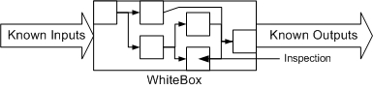
  - Deals with Internal Logic
  - Coding knowledge is required
  - Developers are white box testers
  - Ex: Unit/Integration testing

- Black Box Testing
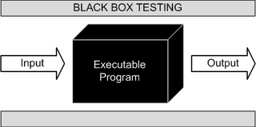
  - Black box testing is a process of checking the functionality of the application against specified requirements
  - Internal System is not considered
  - Tests are based on requirements & functionality
  - It is used to find the following incorrect or missing Implementations of functions
  - External database access
  - Performance errors
  - It is also referred as functional testing, Behavioral testing or opaque testing
  - This is done by test engineers
- Grey Box Testing
- A Grey Box testing is a combination of Black Box Testing and White Box Testing
- It is not fully black box testing because the tester should have the knowledge of internal design of the code
- The application is also tested for its behavior and functionality which forms which is white box testing
- It is also called “Translucent testing”

- White box Vs. Black box testing
White Box Testing | Black Box Testing
Performed by the Developers | Performed by the Testers
The developer should have the knowledge of internal design of the code | No Need
Test the logic of the program | Test the functionality of the application against requirements
Done before black box testing | Done after white box testing
EX :- Loop, Condition, Path Testing | EX:- System, Compatibility, Usability, Performance testing
Tools:- Rational Purify , JUnit/NUnit Frameworks | Tool:- Win runner, QTP, Silk Test, Rational Robot,TC, Test Partner,Selenium, WebDriver

1.5 Testing Levels

  - Unit Level Testing
  - Integration Level Testing
  - System level Testing
  - User Acceptance Testing(UAT)

- Unit Level Testing: - Testing of single program, modules or unit of code.
  - Deliverable: Software unit is ready for testing with other system component.
- Integration Testing
  - Integration testing is a process of combining the modules and testing the data flow between the modules
  - Integration testing verifies that the combined units function together properly
  - This can facilitate finding problems that occur at interface or communication between the individual components
- It is also referred as Assembly testing.
- It is divided into two types
  - Incremental Integration testing
  - Non-Incremental Integration testing
- Incremental Integration Testing
  - Incremental Integration testing is a process of testing in which
Each unit is integrated one at a time into the system
  - The data flow between the modules is tested as soon as a new module is integrated
  - This process consists of systematically combining the unit tested module one by one and testing the combined modules
  - Incremental integration testing is divided into two types
    - Top-Down testing
    - Bottom-Up testing

  - Top-Down Testing
    - Top-down testing is a process of incrementally adding the modules from parent to child and the data flow between the modules.
    - This process works downward through the software hierarchy (Top-to-Bottom).
    - It emphasize on Interface testing.
- Bottom-Up Testing
  - Bottom-up testing is a process of incrementally adding the modules from child to parent and test the data flow between the modules
  - It emphasize on module functionality

- Non-Incremental Integration Testing
  - Non-Incremental integration testing is a process of testing the product by integrating every unit, all at a time into the system and testing the data flow between the modules
  - This method can be used to save time in the integration process
  - It is also called as Big bang Method

- System Testing
  - System testing verifies whether the entire application is working according to the software requirements
  - It is also referred to as Product testing and End-to-End testing
  - System Testing involves some or all of the tests listed below:
  - Compatibility Testing- Testing the functionality on different software/Hardware environments.
  - Usability Testing- Testing the user-friendliness of the application
  - Performance Testing- Testing the performance of the application in terms of response time etc.
  - Security Testing- Testing the Authorization and Authentication levels of the application
- Acceptance Testing
  - Acceptance testing is a process in which testing of the application is done by the end user or client
  - The client tests whether the application meets the requirements given by him
  - It is classified into two types
    - Alpha Testing
    - Beta Testing
- Alpha Testing
  - Alpha testing is done by potential user/customer or an independent testing team at the developer’s site along with the developers or testers
  - It is done before beta testing

- Beta Testing
  - Beta testing is done by potential user/ customer or independent testing team at the customer’s real time environment without any developer or tester involvement
  - It is done before releasing the product to the market

System Testing Types:
- Usability Testing
UI Testing with the intention of look and feel, speed in navigation/interfacing and easy accessibility in terms of navigation.
- Functional Testing

- Functionality or Requirements Testing
i) Successful Functionality
ii) URL’s Coverage
iii) Database or Backend testing
vi) Calculation Coverage
- Input Domain Testing
- Error Handling Testing
- Recovery and Reliability Testing
- Compatibility Testing
- Configuration Testing
- Inter Systems Testing
- Installation Testing (QA Environment)

- Performance Testing i) Load ii) Stress iii) Volume iv) Endurance v) Failover vi) Spike Testing
- Security Testing i) Authorization ii) Access Control iii) Encryption/Description

Accepting Testing:
- Alpha Testing - Core user testing
- Beta Testing - UAT User testing

Installation Testing (Client Environment)

- Testing Methodologies - Waterfall model, V model, Agile model, Spiral model, RUP and RAD

- Testing methods - 1. Black box testing 2. White box testing 3. Grey box testing

- Test Techniques - Are the techniques that are used while conducting Black Box and/or White Box testing
  - Black Box - ECP, BVA, Error Guessing, Cause Effect Graphing, Comparison Testing and Model Based Testing
  - White Box - Basis Path, Loops and Control Structure Testing "

- Testing Types - All kind of testings types used in SDLC like Unit, Integration, Usability, functional, performance and Security testing and further divisions as below

1.6 Testing types

- Smoke testing
  - Smoke Testing is a test done before the application goes into the actual testing phase
  - The tester touches all areas of the application without getting in too deep
  - This test reveals any simple failure and ensures that the system is ready for further testing
  - For Example:
    - Smoke test is done to check whether the link or button does some action. If the answer is “no” then the condition fails
- Sanity testing
  - A Sanity test is used to determine a small section of the application is still working after a minor change
  - A sanity test is usually unscripted
- Usability Testing
How simple customer can browse the website or user friendliness.
  - Usability Testing is done to test the user friendliness of the software
The following areas are tested for usability
    - Keyboard & mouse operations
    - Spellings & grammatical mistakes
- User Interface (GUI) Testing
  - Verifying the User interface of the application means how the frontend design, font color, Text format, Labels, background, foreground etc.
  - This is the process of verifying the look and feel environment of the application.
- Functional Testing
  - In Functional testing the application is tested for functional requirements.
  - Different types of input (test data) are given for testing the functionality of the component.
  - Functional Testing is also called as specification-based testing.
- Re-testing
  - Reproduce the steps and verify whether the bug has been fixed or not
- Regression Testing
  - Regression Testing is retesting the application just to make sure that the bug has been fixed and its impact on the rest of the application
  - It is divided into three types:
  - Unit Regression testing – Re-executing the same test cases on a particular unit or module due to requirement change
  - Regional regression testing- Re-executing the same test cases in two or three modules due to requirement changes
  - Full Regression testing – Re-executing the test cases in all modules due to a requirement change
- Database Testing
  - What is Database?
    - Database is a Collection of Data
    - Database are Organized by Fields, Records and Files.
    - A Field is a Single Piece of Information.
    - A Record is One Complete Set of Fields.
    - A File is a Collection of Records
  - Database
    - Two types of errors that may occur in web application.
    - Data Integrity: Missing or wrong data in table.
    - Output Errors: Errors in writing, editing or reading operation in the table.

- Compatibility Testing
  - Compatibility testing is a process of testing the functionality of an application on different hardware and software environments
  - The application is tested for the environments which are specified by the client
  - For Example:
    - Test the application on different operating systems such as Windows all versions, Macintosh, Linux and UNIX.
    - Test the web application on different browsers such as Internet Explorer, Mozilla Firefox, Netscape navigator and Opera.
- Adhoc Testing
  - Testing carried out informally
  - No formal test preparation takes place
  - No recognized test design technique is used
  - No expectations for results and randomness guides the test execution activity

- Exploratory Testing
  - Exploratory testing is an approach of software testing where there is simultaneous exploring the application, preparing the test design and test execution
  - When performing this test there are no exact expected results, the tester decides what will be verified
  - It is done when requirements are incomplete or there is a lack of time
  - Ad-hoc testing is a part of Exploratory Testing where the test is run once, unless a defect is discovered.
- Security Testing
  - Security Testing is a process of testing an application/Product how well it is protected from unauthorized entries.
  - It is used to find out all the potential loopholes and weaknesses of the system.
  - Through this testing we can prevent the loss/theft of highly sensitive information from the outsider.
  - It ensures that the system and application used by the organization are secure and not exposed to any type of attack.
- Recovery Testing
  - Recovery testing is a process of testing the application in order to check how well the application recovers from any type of crash or hardware failure
  - It is tested for the system’s ability to recover at varying degrees of failure
- Installation/ Uninstallation Testing
  - Installation testing is defined as test which occurs outside the development environment
  - This test is performed whenever a full, partial or upgrades of the application are installed/ uninstalled.
  - It is also referred to as implementation testing & Software deployment testing

- Performance Testing
  - Performance testing is a group of tests which test the following aspects
    - Response time
    - Execution time
    - Volume
    - Scalability
- Types of Performance Testing
  - The different types of Performance tests are as follows
    - Load Testing- The application/Product is tested against fixed number of users in order to find out the stability and response time of the product
    - Stress Testing- is done to evaluate if the application is stable at peak load i.e. beyond the limits of its specified requirements
    - Volume Testing- is done to test stability of the system by processing huge amount of data
    - Soak Testing- is done by applying significant load over an extended period of time, to discover how the system behaves
1.7

Module 2: Process - Software Engineering

2.1 Introduction to Software Engineering
- What is SE
  - SE is a technological and managerial discipline concerned on a development and maintenance of a software projects or products on time and with in cost estimates.
- Important factors in software developments
  - Time
  - Budget/Cost
  - Quality
- Reusability
  - Capability of reusing a system
  - One of the important characteristic of software engineering is reusability.
- Advantages of Re-usability
  - Productivity will be increased.
  - Development time is reduced.
  - Testing time also reduced.
  - Overall project delivery time is reduced.
  - Budget is saved.
- Software Process – Pros & Cons
- Process
  - A sequence of steps performed for a given purpose.
  - A set of activities, methods and transformations, practices that people use to develop and maintain a system.
- Advantages
  - Quality
  - Consistency
  - Traceability
  - Early defect removal reduced
  - Re –work and rejections
  - Control of Cost
  - On time
- Dis advantages
  - Commitments consistently missed
  - Late delivery
  - Last minute crunches
  - Quality problems
  - Too much reworks
  - Functions do not work correctly
  - Customer complaints after delivery
  - People frustrated

2.2 Project Management Process
- One can accomplish the Project Management with the following processes
- Project Manager is the person who is responsible to accomplish the Project Objectives

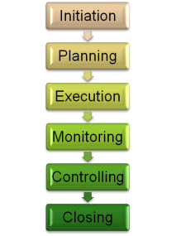

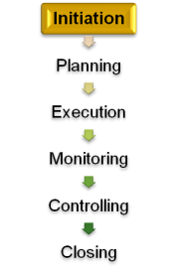
- Project Initiation
  - Input – Final Proposal (SOW)
  - Major Activities
  - Identify project manager
  - Conduct project kick off meeting.
  - Identifying risks, resources and process or methodology for the project.

- Project Planning
  - Major Activities
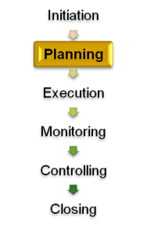
  - Setting project objective and quantitative goals
  - Requesting for identified resources
  - Prepare project management plan
  - Development Plan, Change Management Plan & SQA Plan
  - Get the PMP approved.
  - Base line the PMP.
  - Identification of members for Change Control Board (CCB), Change Management (CM).

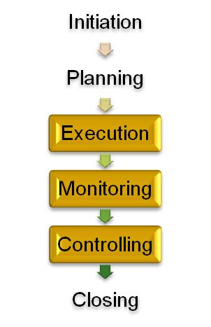
- Project Execution/Monitoring/Controlling
  - Major Activities
  - Executing the PMP (performing the all activities).
  - Track project activities.
  - Track project progress.
  - Track issues, risks complaints and resources.
  - Track project changes & cm activities.
  - Review project progress.
  - Metrics analysis—monthly
  - Initiate corrective & preventive actions.
  - Revising the plan schedules
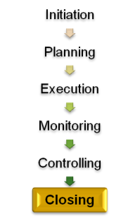
- Project Closure
  - Major Activities
  - Intimate project closure to SQA & affected groups.
  - Perform closure analysis
  - Conduct closure meeting
  - Submit metric analysis to SQA.
  - Release resources

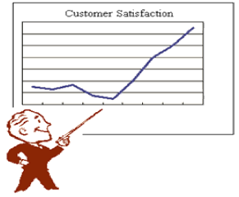
  - Customer Satisfaction Survey
  - Major Activities
  - Plan for Survey – Every quarterly
  - Send the satisfaction survey to customer.
  - Obtain the feedback
  - Review the feedback & come up with the Action Plan on the Improvements Areas
  - Submit the same to SQA team

2.4 Requirement Change Mgmt or Change Request
  - Major Activities
  - Prepare change request
  - Perform impact analysis (work product, effort ,schedule)
  - Re-estimate delivery schedule

  - Review impact with senior management and other affected groups, as necessary
  - Obtain approval from change control board
  - Obtain customer sign off
  - Implement the approved changes in the work item.
  - Perform review /testing process to verify the implementation of change.
  - Update closure status of change request.

2.5 Software Configuration Management
- The Process of identifying, organizing and controlling changes to the software during development and maintenance.
- SCM is a support activity that makes technical and managerial activities more effective.
- SCM operates throughout the software life cycle.
- A methodology to control and manage a software development project.
- Purpose of SCM: Establish and maintain the integrity of work products.
- Why do we need SCM?
- To Manage:
  - Multiple people have to work on software that is changing.
  - Projects derived in several releases (builds).
  - Software must run on different machines and operating systems (Rapid evolution of software and hardware).
- Problems resulting from Poor Configuration Management:
  - Can’t roll back to previous sub system.
  - One Change overwrites another
  - Which code changes belong to which version?
  - Faults which were fixed Re-Appear
  - Tests worked perfectly on Old version
  - “Shouldn’t that feature be in this version?”
- Using Configuration management:
  - Multiple Testers-Concurrent Accesses.
  - Orderly Control of change
  - View differences
  - Rollback changes
  - Release management
  - History
  - One of the Key Process Areas in SEI CMMI Level2
- Major Activities:
  - Configuration planning & Setup
  - Configuration identification
  - Configuration Baseline
  - Change Management
  - Configuration Release Control
  - Configuration Audit
  - Control of customer Property
- SCM-How it is accomplished?
  - All these goals are accomplished through ‘Version Control’
- Version Control:
  - Commonly used in engineering and software development
  - Changes identified by incrementing an associated number.
- Done in Two ways:
  - Manually
  - Automation
- Manually: In company server, administrator creates the project folder and he can provide the access permissions to all users (project members)
- Automation – SCM systems:
- Open source:
- CVS-http: // cvshome.org/
- Subversion-http: // subversion.tigris.org/
- Darcs-http://www.abridgegame.org/darcs/
- Commercial:
  - PVCS – http://www.pvcs.synergex.com/
  - Perforce – http://www.perforce.com/
  - Visual Source Safe – http://www.microsoft.com
- How does Automation Works:
  - VSS and CVS use a client/server Architecture.
  - A system admin would normally install the server.
  - The server maintains the repository (database).
  - Developers and Testers use the Client
  - The client allows for check in, check out the files etc.
- Sample List of Configuration Items:
  - Management plans (project plan, Test plan etc.)
  - Specifications (Requirements, Design, Test case, etc.)
  - Customer Documentation (Implementation Manuals, User Manuals, On-Line help files)
  - Source code (Java, Net, PHP, Visual Basic, etc.)
  - Executable code (exec’s, etc.)
  - Libraries (Packages, %include files, API’s, DLL’s, etc.)
  - Databases (Data being processed, test data, etc.)
  - Production Documentation.
- Vocabulary:
  - Repository: A server where the files are stored.
  - Check-out: Copies a working copy from the repository.
  - Check-in:
    - Copy the changes on the local files to the directory.
    - The Version Control software takes care of changes since the last synchronization.
  - Undo checkout (uncheck-out):
    - The “undo check out” command does just that the file returns to the status it had before it was checked out.
    - This can be done even if changes have been made to the local copy-of course, these do not go onto the database.
- Navigation to Microsoft VSS 6.0(visual source safe):
  - It is commercial software from Microsoft
  - Software is available in two types.
  - VSS server Software
  - VSS client software
  - VSS server software is installed on organizational server machine by administrator
  - VSS client software to be installed into our local machines(project members machines).
  - Administrator will create the users for VSS and he will provide access permissions for all users (project members) to access VSS Repository.

Start
|
Programs
|
Click on Visual Source safe
|
Observe VSS Login Window
|
Enter Username, password & Click on ok]
|
Observe VSS Homepage is displayed

- The Test Engineer Responsibilities are
  - Copy Files(Check-out)
  - Check-in Files

2.6 Process & Process Model

- Process & Quality
  - A process is a set of practices performed to achieve a given purpose, it may include tools, methods materials and for people.
  - “The quality of a product is largely determined by the quality of the process that is used to develop and maintain it.”
- What is Process Model:-
  - A model is a structured collection of practices that describe characteristics of effective processes.
  - A process model is roughly an anticipation of what the process will look like.

- SEI CMMI - Background

The need for software processes prior to CMM
  - In the 1970s, the processes for software development were in their infancy, with few standard or "best practice" approaches defined.
  - As a result, the growth was accompanied by growing pains: project failure was
  - Common, and the field of computer science was still in its infancy, and the ambitions for project scale and complexity exceeded the market capability to deliver.
  - In the 1980s, several US military projects involving software subcontractors ran over-budget and were completed much later than planned. In an effort to determine why this was occurring, the United States Air Force funded a study at the SEI.

- SEI
  - “Software Engineering Institute” at Carnegie Mellon University initiated by the U.S defense department to help improve software development processes .

- SEI CMMI

- CMMI (Capability Maturity Model Integration)
  - CMM = The Capability Maturity Model for software has been retired and CMMI(Capability Maturity Model Integration) replaces it, and it is developed by the SEI.
  - A maturity model can be used as a benchmark for comparison and as an aid to understand the process
  - For example, for comparative assessment of different organizations where there is something in common that can be used as a basis for comparison. In the case of the CMM, for example, the basis for comparison would be the organizations' software development processes.
  - The CMM was originally intended as a tool to evaluate the ability of government contractors to perform a contracted software project.
  - Organization can receive CMMI ratings by undergoing assessments by qualified auditors.

- CMMI Levels
  - It’s a model of 5 levels of process maturity that determine effectiveness in delivering quality software.
  - Each maturity level provides a layer in the foundation for continuous process improvement.

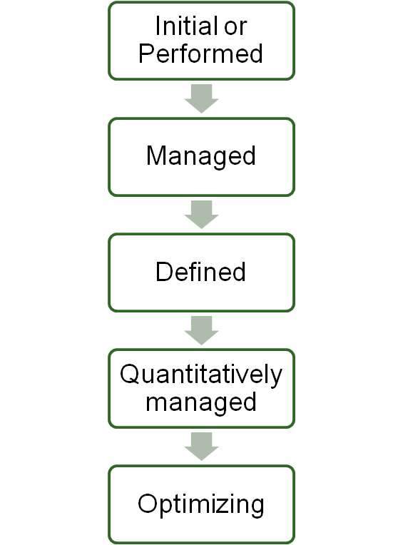

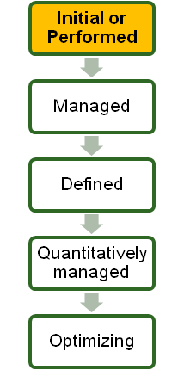
- CMMI Level 1 - Initial or Performed Level
  - Totally ADHOC processes. The organization usually does not provide a stable environment.
  - Success in these organizations depends on the competence and heroics of the people in the organization and not on the use of proven processes.
  - Organization may not have a schedule, budget, scope or quality though there may be some excellence.
  - Typically undocumented and in a state of dynamic change,
  - Uncontrolled and reactive manner by users or events.
  - Initial Overview:
    - Introduction
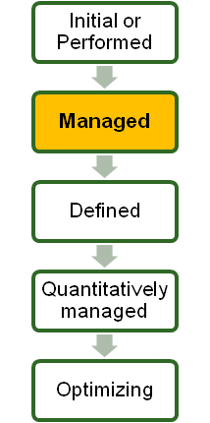
    - Structure of the model.
    - Understanding the model.
    - Using the model.

- CMMI Level 2 - Managed
  - Project level processes are established.
  - Requirements are managed, and that processes are planned, performed, measured, and controlled..
  - Some processes are repeatable, possibly with consistent results.
  - The status of the work products and the delivery of services are visible to management at defined points.
  - Key Process Areas(KPA’s)
    - Requirements management
    - Project planning
    - Project monitoring and controlling
    - Supplier agreement management
    - Measurement and analysis
    - Process and product quality assurance
    - Configuration management

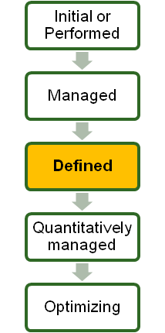
- CMMI Level 3 - Defined
  - At this level that there are sets of defined and documented standard processes established and subject to some degree of improvement over time
  - These standard processes are in place and used to establish consistency of process performance across the organization.
  - An engineering process group EPG is formed, a QMS document is generated, continuous training
  - Programs are conducted and engineering and management activities are well aligned.
  - Key Process Areas(KPA’s)
    - Requirements development.
    - Technical solution.
    - Produced integration.
    - Verification.
    - Organizational process focus.
    - Organizational process definition.
    - Integrated project management.
    - Integrated supplier management.
    - Organizational training.
    - Risk management.

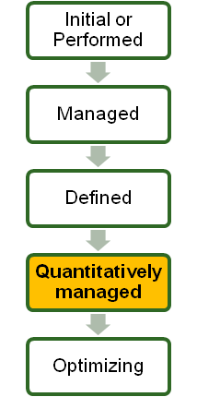
- CMMI Level 4 – Quantitatively Managed
  - Process Capability is established from this level.
  - Here, quantitative data gets collected from all process, using statistical tools, the data is analyzed and all projects are managed using quantitative information.
  - If your adventure with CMMI begins on level 4 program it means you are entering High Maturity CMMI.
  - There are two process areas in this level. The problem is that it takes lot of effort to implement them.
    - QPM - Quantitative Project Management
    - OPP - Organizational Process Performance

- QPM - Quantitative Project Management
  - The purpose of QPM is to quantitatively manage the PDP - project defined process to achieve the quality and process performance objectives.
  - To make it simpler to understand - you have to know at any moment if your project will meet its targets and objectives.
- OPP - Organizational Process Performance
  - Another process which needs to be implemented in order to meet CMMI level 4 requirements is Organizational Process Performance.
  - There must be established baseline and model to manage organizational processes.

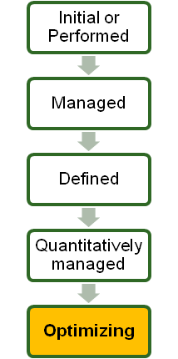
- CMMI Level 5 - Optimizing
- At this level that the focus is on continually improving process Performance through both incremental and innovative technological changes/improvements.
- This is the optimizing level where a continuous improvement of the process is carried out using new techniques, tools and technology.
- The areas of weaknesses are identified using cause and effect diagrams, Pareto analysis etc and variations eliminated.
- A Cost- Budget analysis is carried out to identify priority areas for improvement.

2.7 VERIFICATION (QA) & VALIDATION (QC)
- Verification (SQA):
  - Identify the Standards and Guidelines
  - Process Oriented
  - Preventing Problems
  - Continuous Improvement
  - Audits ( Check for Conformance )
- Verification Overview:
  - Verification is the process of finding whether the product is developed correctly.
  - It is a process of finding whether work product complies with the design specifications.
  - The work product is assessed by one or more persons to check the correctness.
- Verification Methods:
  - The following are some of the Verification methods:
    - Inspection
    - Walkthroughs
    - Buddy Checks

- Inspection:
  - The main goal of inspection is to find the defect and to convey the information about the product.
  - It involves a team of 3-6 members
  - It is headed by a unbiased moderator
  - Each member will be viewing the product from different angle.
  - It needs individual preparation by the members before going to the meeting.
  - The presenter is not the author of the document.
  - Presenter reads the document, while others view it from different perspectives.
  - This team finally comes out with an inspection report and the facts on errors/Issues.

- Walkthroughs:
  - In walkthrough the participants attend the meeting where the presentation about the product is given and they give their comments in form of reports.
  - It gives a chance for the participants to familiarize with the product.
  - This team is led by the creator of the document who would also present the work product.
  - The team size usually is between 2-7 members.
- Buddy checks:
  - Buddy check is an informal peer review.
  - It is performed by someone other than the creator.
  - One team member goes through the documents prepared by another member in order to find out if there are any bugs which the author couldn’t find out if there are any bugs which the author couldn’t find previously.
  - This testing is done in situations where it is not suitable or impossible to conduct inspection or formal review.
- Verification Activities:
  - Verification activities include verifying the following documents:
    - Software Requirement Specification(SRS)
    - Functional design
    - Internal design
    - Code
    - Test Plans

- Validation (SQC):
  - Implement the Standards and Guidelines
  - Product Oriented
  - Detecting Problems
  - Final Checkpoint before Delivery

- Validation:
  - “Validation” Checks Whether we are Building the Right System, and “Verification” Checks Whether we are Building the System Right.
- Validation Strategies Comprise of the following:-
  - Unit Level Testing
  - Integration Level Testing
  - System level Testing
  - Alpha Testing
  - User Acceptance Testing(UAT)
  - Installation Testing
  - Beta Testing

2.8 Testing Roles & Responsibilities

- Testing Roles:
  - Software Test Engineer (SE)
  - Senior Software Test Engineer (SSE)
  - Test Lead (TL)
  - Test manager(TM)
  - Sr.Test Manager
  - Assoc.Div/Dir-Software Testing
  - VP-Software Testing
- Software Test Engineer Responsibilities:-
  - Understanding the Requirements and Functional specifications of the application.
  - Identifying required Test scenarios for Project
  - Designing and Preparing Test cases to validate application
  - Execute Test cases to validate application
  - Logs test results (How many test cases pass or fail)
  - Defect reporting and tracking.
  - Retest fixed defects of previous build.
  - Performed various types of testing assigned by Test Lead(Functionality, usability, user Interface and Compatibility etc)
  - Reports to test Lead about status of assigned tasks
  - Daily Status Report
  - Daily Defect Report
  - Weekly Status Report
  - Retesting Report
  - Other assigned tasks any
  - Participated in Regular team meetings by lead and manager
  - Provides enhancements to project based on End user perspective
  - Provides recommendation on whether or not the application/system is ready for production.
- Senior Software Test Engineer Responsibilities:-
  - Same as test engineer responsibilities
  - He is participated in Review of Test Scenarios, Test cases and Defects.
  - Some Times he is involved in preparation of Test Plan also.
  - Whenever Test lead on vacation ,he will Lead the Team(backup for Test lead)
- Test Lead Responsibilities:-
  - Task Preparation
  - Task allocation to team members.
  - Training team members
  - Team management
  - Bug Reviews
  - Test Scenario and Test case Development for new enhancements
  - Test Scenario and Test case Reviews
  - Preparation of Build Summary report
  - Conducting meeting with in team members
  - MOM Preparation
  - Co-ordinates overall Test team activities
  - Test Plan Preparation
- Test Manager Responsibilities:-
  - Project and Test plan preparation
  - Effort estimates
  - Project management
  - Training Plan –Identify training needs and Resume Skill gaps and initiate training(internal or external)
  - Project Configurations and Training
  - Identifying scenarios for Testing
  - Weekly summary Report
  - Client Communications
  - Mom’s
  - Managing support activities and trainings
  - Provides regular status updates to core Team
  - Schedule meetings with development team/ Testing team

- Testing Terminology:-
  - BRS-Business requirement Specification
  - SRS-software Requirement specification
  - RTM- Requirements Traceability matrix.
  - TP-Test Plan
  - STE-Software Test Engineer
  - SSTE- Senior Software Test Engineer
  - TL-Test lead
  - LOC-Lines of Code
  - SQA-Software Quality Assurance
  - SCM-Software Configuration Management
  - FRS-Functional Requirement Specification
  - IPMP-Integrated Project management Plan
  - P1-priority1
  - P3-Priority3
  - SEPG-Software Engineering Process Group
  - SEI- Software Engineering Institute

Question & Answers

- What is the Configurable Items Identified for the Project?
  - Test Plan, Requirements, Design Specifications, Test Scenarios, Test Cases and Code.
- How is the Changes/Change Request Tracked? Please Explain?
  - Using Version control.
- Who is the Configuration Controller for your Current Project?
  - My Test Lead.
- What is the Configuration Tool Using for the Project?
  - Microsoft Visual Source Safe 6.0.
- How Do You Maintain the Configuration Management for Controlling Work Products?
  - Using Version Control.
- What are the Non-Configurable Items for the Project?
  - MOM’s, Status Reports, Review Records and Mails.
- What Kind of Configuration Audits were Conducted for Your Project?
  - Baseline Audits, Release Audits

- What are all the Baseline Documents and Explain Baseline Strategy?
  - A Specification / Product / Deliverable that has been formally Reviewed, and Agreed to by Responsible Management that Thereafter Serves as the Basis Further Development.
- Please Explain the Contents of SCM Plan?
  - Introduction:
    - Describes Purpose, Scope of Application, Key Items and References.
  - Scope:
    - Define Limitations of Configuration Management.
  - Management: (WHO)?
    - Identifies the Responsibilities and Authorities for Accomplishing the Planned Configuration Management Activities ( Configuration Manager, Configuration Controllers and Configuration Users ).
  - Activities:
    - Identifies the Activities to be Performed in Applying to the Project.
  - Schedule :( WHEN)?
    - Establishes the Sequence and Co-Ordination of the SCM Activities with Project Mile Stones.
  - Resources :( HOW)?
    - Identifies Tools and Techniques Required for the Implementation of the SCMP.
  - Maintenance:
    - Identifies Activities and Responsibilities on how the SCMP will be kept Current during the Life-Cycle of the Project.

Module 3: Project

Project Management Plan
Purpose
To manage the project
The objective of a project Management plan is to define the approach to be used by the project team to deliver the project deliverables with in the time frame
Is a formal, approved document that defines how the project is executed, monitored and controlled?
The project manager creates the project management plan following input from the project team and key stakeholders.
The plan should be agreed and approved by at least the project team and its key stakeholders.


Project Plan
a statement of how and when a project’s objectives are to be achieved, by showing the major products, milestones, activities and resources required on the project.”
A project plan might not be a single document. In fact it is usually a collection of several plans including schedule, budget plan, risk management plan, procurement plan, etc. Some folks prefer putting all these in one document, while others prefer keeping them separated. However, the point is that project plan consists all necessary plans for running a project.

PMP – Entry & Exit Criteria
Entry Criteria
RFP
Sow or work order
Project plan template
Exit Criteria
Project plan should be reviewed and approved once PMP is approved
Configuration controller will create base line for PMP(PMP1.0)
Update the document in Configuration Repository either file server or VSS.

Main aspects of PMP
The project management plan typically covers topics used in the project execution system and includes the following main aspects:
- Scope Management
- Schedule Management
- Financial Management
- Quality Management
- Resource Management
- Communications Management
- Project Change Management
- Risk Management
- Procurement Management
Contents in PMP
Introduction
- Purpose
- Scope
Project Description
Commitments made to customer.
Quality objectives and goals of the project.
Project initial & Revision of estimates
- Size estimation
- Effort estimation
- Schedule estimation
Project organization and Responsibilities.
Client Responsibilities
Software development life cycle (SDLC) model.
Requirements management plan
Risks
Risk Identification
Risk Strategy
Resources Required
Human Resources
Special tools and techniques required
Environment Details
Development environment
Test environment
Work breakdown structure
Deliverables
Project Reviews
Peer Reviews
Project Training needs
Quality activities/plans
SQA Plan
Test Plan
Configuration Management Plan
Data Management Plan
Defect Prevention Plan
Other Plans

Requirement Documents
Differences between the Requirements
Requirement
A condition or capability needed by a user to solve a problem
a requirement is a singular documented need of what a particular product or service should be or perform
It is most commonly used in a formal sense in systems engineering or software engineering.
In the classic engineering approach, sets of requirements are used as inputs into the design stages of product development
Requirements are also an important input into the verification process, since tests should trace back to specific requirements.
Requirements show what elements and functions are necessary for the particular project.
Business Requirement Specs
A business requirements document (BRD) details the business solution for a project including the documentation of customer needs and expectations.
Business requirements should focus on what the client wants, not how they want it.
The BR describes what the system would look like from a business perspective.
The BR distinguishes between the business solution and the technical solution
The BR is important because it is the foundation for all subsequent project deliverables, describing what inputs and outputs are associated with each process function.
Once the complete requirements are gathered, the solution should be discussed. There may be more than one type of solution that will meet the resource availability, etc. and will help in estimating the time required to deliver the solution to the client.
Objectives of BRD
The most common objectives of the BRD are:
To gain agreement with stakeholders.
To provide a foundation to communicate to a technology service provider what the solution needs to do, to satisfy the customer's and business’ needs.
To provide input into the next phase for this project.
To describe how the customer/business needs will be met by the solution.
Example:
For example, the business wants to serve 100 bottles of red wine each night during a three-day conference and the wine must be 57 degrees Fahrenheit when poured.
The technical solution should support the business solution. For example, the company would need a wine grotto or refrigeration storage unit capable of holding 300+ bottles operating between 48 and 52 degrees Fahrenheit.

System Requirement Specs
SRS(Software Requirement Specification) document will describe about what the client is expecting from the system/application/project/product.
It consists of real time usage of the system.
A good SRS should have the characteristics of: correct, unambiguous, complete, consistent, verifiable, modifiable, traceable.
An SRS should be jointly prepared by the customer and supplier (of the software)
The SRS should only contain product requirements, not project requirements, i.e. it should not contain costs, schedules, development methods, acceptance procedures, etc.
SRS is implemented form of BRS
Is a description of an organization's understanding of customers or a potential client's system requirements and dependencies.
It's initial purpose is to ensure that the provider understands the customers' or client's requirements prior to any actual design or development.
Ex:
If you take Yahoo site, first page should be login, to access mailbox user should be authenticated, user can able to see all his received mails, user can send mails to recipients etc......
SRS Prepared by the devs TL/PM/PL by taking inputs from BRD
The contents of SRS are Use Case, Use Case diagrams, Task flow diagrams, pictorial diagrams, actors, pre conditions, post conditions etc.
It is a system requirement specification document which will define the software, hardware requirements which one has to use in the project.
Functional Requirement Specs
FRS (Functional Requirements Specification) document will describe how the requirements will be developed.
The documentation typically describes what is needed by the system user as well as requested properties of inputs and outputs.
All the conditions, validation as well as the process is mentioned in FRS.
It will be more detailed functional knowledge of the system
To develop the system, what technologies should be used, to login what inputs should be provided, In Inbox what are the fields should displayed, how the user composes the mail etc.....
To be frank, there is only one or 2 documents that a company would follow and these terms are often interchanged.

Software Requirement Specification
SRS – Software Requirement Specs
SRS
An SRS is basically an Organization Understands of a customer or client’s system requirements and dependencies at a particular point in time prior to any actual design or development work
It’s a two way insurance policy that assures that both the client and the organization understand the others requirement.
A well written SRS accomplishes four major goals:
It provides feedback to the customer. An SRS is the customer’s Assurance that the development organization understand the issues or necessary to address those problems.
It decomposes the problem into component parts
It serves as an input to the design specification
It serves as an input to the testing for product validation check.

Contents in SRS

Introduction
Project Overview
Project Objective
Existing System
Constraints & Limitations
Proposed system
System overview
Need for the proposed system
Automation
Requirements
Project Requirements
Project System
User Management

INTRODUCTION TO SOFTWARE TESTING LIFECYCLE
Software Testing Life Cycle (STLC):

In general software testing starts from the requirements analysis phase and ends with deployment phase

Stages of STLC:
Software testing life cycle contains the following stages
Requirement Analysis
Test plan preparation
Test case preparation – Test Procedure, Test Design and TRM
Test Execution
Result Analysis
Defect tracking
Test execution report and QA Sign-off

Requirements Analysis:
Going through the requirement documents to understand the expectations of customers is called Requirement analysis.
In this process the tester becomes familiar with the requirements.
The test scenarios are derived from the requirements.

Test Plan Preparation:
Test plan is a document which contains the following information

Objectives
Scope of testing
Approach to be followed
Schedule
Outputs or deliverables
Risks and Contingency plans
Estimates
Roles and Responsibilities
Test Case preparation
A Test case is a set of test conditions which the tester uses to determine whether a requirement or use case has been satisfied in the application
They are derived from the test Scenarios
A Test case consists of
- Header- test case name, project name, severity
- Body-description, input, expected result.
- Footer-author, reviewer name.

Prepare Requirement Traceability Matrix (RTM):
Requirement Traceability Matrix (RTM) is a document which maps the test case with the requirement.
This document is used to Validate that the requirements are correct and complete
Check if all the requirements are addressed by some components of the application
Check if all the application components are addressing some requirements
Illustration of RTM:

Test Execution:
Test Execution is done by executing the test cases against the application/product or executing by using an automation tool.
Read the description in test steps which is given in test cases and apply the test data on the application.
Once executed the test cases, will get the actual results.
Compare the expected result with actual result then fill the status of the test case.

Defect Tracking:
Defect Tracking is a process of finding defects in an application by inspection or testing.
A defect arises when the expected result and actual results are not the same.
The defects are documented in the system investigation Request (SIR) or defect tracking tools.
The defects are fixed and the testers re-test the application to ensure full resolution of the defects.

Test Execution Report:
All executed test cases will be delivered to the client. This is called as test execution report.
The test execution report includes information like tester’s name, module name, build no, date of execution, actual result and status.
Along with test cases, test plan, requirements traceability matrix and defect report will be delivered to the client.

Test Strategy
A Test Strategy document is a high level document and normally developed by project manager. This document defines “Software Testing Approach” to achieve testing objectives. The Test Strategy is normally derived from the Business Requirement Specification document.

The Test Strategy document is a static document meaning that it is not updated too often. It sets the standards for testing processes and activities and other documents such as the Test Plan draws its contents from those standards set in the Test Strategy Document.

Some companies include the “Test Approach” or “Strategy” inside the Test Plan, which is fine and it is usually the case for small projects. However, for larger projects, there is one Test Strategy document and different number of Test Plans for each phase or level of testing.

Components of the Test Strategy document
Scope and Objectives
Business issues
Roles and responsibilities
Communication and status reporting
Test deliverability
Industry standards to follow
Test automation and tools
Testing measurements and metrices
Risks and mitigation
Defect reporting and tracking
Change and configuration management
Training plan

Test plan: What to Test, how to test, who to test and when to test

Test Plan
The Test Plan document on the other hand, is derived from the Product Description, Software Requirement Specification SRS, or Use Case Documents.
The Test Plan document is usually prepared by the Test Lead or Test Manager and the focus of the document is to describe what to test, how to test, when to test and who will do what test.

It is not uncommon to have one Master Test Plan which is a common document for the test phases and each test phase have their own Test Plan documents.

There is much debate, as to whether the Test Plan document should also be a static document like the Test Strategy document mentioned above or should it be updated every often to reflect changes according to the direction of the project and activities.
My own personal view is that when a testing phase starts and the Test Manager is “controlling” the activities, the test plan should be updated to reflect any deviation from the original plan. After all, Planning and Control are continuous activities in the formal test process.

Test Plan id
Introduction
Test items
Features to be tested
Features not to be tested
Test techniques
Testing tasks
Suspension criteria
Features pass or fail criteria
Test environment (Entry criteria, Exit criteria)
Test deliverables
Staff and training needs
Responsibilities
Schedule

This is a standard approach to prepare test plan and test strategy documents, but things can vary company-to-company

INTRODUCTION TO TEST PLAN
Test Plan:
- Test plan describes the intended scope, approach, resources and schedule of the testing activities.
- The test lead prepares the test plan.
- The purpose of test plan is to manage, organize and schedule the testing activities effectively.

In this detailed test planning the test lead is followed the below process.
- Requesting For identifying the resources
- Identify team level risks
- Prepare detailed test plan
- Review test plan

SNO | REQUIREMENTS | TESTCASE
1 | Login Page | Test case001
2 | Home page | Testcase002
3 | Inbox page | Testcase003
4 | Compose page | Testcase004

From the above model the detailed test plan is derived from test strategy (or) test methodology (or) master test plan by test lead.
Contents of Test Plan:
- Objective & Scope
- Approach
- Testing Environment
- Deliverables
- Roles and Responsibilities
- Assumptions
- Risks & Contingency plan
- Effort Estimation
- Schedule
- Testing Methodologies
- Defect Tracking
- Test Automation
- Suspension criteria
- Resumption criteria

Objective & Scope:
The Objective explains the need and importance of test plan
The Scope talks about the features which need to be tested and the features which need not be tested.
For Example
Features to be tested would be user Required modules with clear priority levels defined (H, M, L).
Features not to be tested can be features which are not part of the current release
Approach/Test Strategy:
Approach describes the strategy which is appropriate for a particular level.
It can include information on tools to be used, metrics, software and hardware details, Regression testing approach
Types of Testing:
- Smoke Testing
- Usability Testing
- User interface testing
- Data Base Testing
- Compatibility testing
- Security Testing
- Performance Testing

Testing Environment:
Testing Environment describes the resources required for the testing environment.
The requirements for a test environment can be special hardware requirements, specific versions of supporting software.

Testing Methodologies:
Testing Methodologies provide the information about the testing methods to be used.
These methodologies may vary from project to project.

Deliverables:
Deliverables are the outputs which are delivered at the end of each stage of testing.

Some of the deliverables are test plan, test cases, requirement traceability matrix, defect reports, test execution report, metrics.

Roles and Responsibilities:
It describes the people and their tasks
Test manager
Write or review test plan
Estimate resource management and people management
Test lead
write or review test plan
Monitor the work done by the test engineers and make sure that all are computing their work within schedule.
Consolidate the report sent by the test engineers and communicate it to management/customer.
Test Engineer: “XXX”
Review test plan
System study, write scenarios, writes test cases for “pqr” and “xyz” modules.
Prepare requirement traceability matrix.
Execute test cases for “pqr” and”xyz”
Communicate the defect report to development team and track defects.

Test Engineer:”XYZ”
Review test plan
Set up the test environment and install the product.
Identify the scenarios for automation.
Automation of identified regression test cases.
Execution and maintenance of automated test cases.

Assumptions:
Assumptions documents the prerequisites of the test, which if not met could have a negative impact on the test.
All the planning ate based on assumptions.
For example test budget, availability of testing environments.

Risks and contingency plan:
Risks in the Testing Process can be defined as follows
Lack of resources when training begins
Delay or Lack of Training on the application or tools used
Requirements getting changed
Application begin delivered late

Contingency plan is prepared as a part of analyzing risks and used whenever the risk occurs.

Effort Estimation and Schedule:

Effort Estimation is estimation of time, resource and cost for testing the project.
Schedule is planning the start date and end date of all the testing activities.

Defect tracking:
Defect tracking is done by using Defect tracking tool or test management tool.
The defect report is the primary document used to track and resolve defects discovered during testing.
Some of the attributes mentioned in the tool are severity, priority status etc., of the defect.
These attributes can have the following values
Severity: critical/major/minor
Priority : high/medium/low
Status : open/assigned/fixed/closed
Test Automation:

Test automation is the part of the test plan which defines the tools to be used for Testing. Defect tracking and other testing activities in the test plan.
It also describes automation framework.

Suspension / Exit Criteria

If any defects are found which seriously impact the test progress, the Team Lead may choose to suspend testing. Criteria that will justify test suspension are:

- Hardware/software is not available at the times indicated in the project schedule.
- Source code contains one or more critical defects, which seriously prevents or limits testing progress.
- Assigned test resources are not available when needed by the test team.

Resumption Criteria

If testing is suspended, resumption will only occur when the problem(s) that caused the suspension has been resolved. When a critical defect is the cause of the suspension, the “FIX” must be verified by the QA before testing is resumed.

*****************************************************************

Test Scenarios & Test Cases

Test Scenario
A possible area to be tested (Or) What is to be tested.
Entry Criteria for identifying test Scenarios:
Approved Test Plan
Approved SRS
Test Scenario template
Any design documents available (if any)
Exit Criteria for test Scenarios:
Test scenarios should be reviewed & approved.
Once test Scenarios are approved test lead will create a baseline for test Scenarios (TS1.0v) and he will update the same into VSS or File server.

INTRODUCTION TO TEST CASES
What is a Test Case?
The test case is a combination of description, input and expected result developed for a particular intention to conform the compliance of a requirement.

Test Case Design Techniques
Why test techniques
Exhaustive testing (Use of all possible inputs and conditions) is impractical.
Need thought processes that help us to select test cases more intelligently
Test case design techniques are such thought processes through which we can intelligently identify the test cases
What is testing technique?
A procedure for selecting or designing tests based on a structural or functional model of the software
Successful at finding faults
It is one of the Best Practice
A way of deriving good test cases
A way of measuring a test effort

Advantages of techniques
Different people: Similar probability of finding faults
Effective testing: to find more deviations (faults)
One can focus or pay more attention on specific types of faults
Know you are testing the right thing
Efficient Testing: to find faults with less effort
Avoid duplication
Identify the best possible combinations to cover maximum conditions

Test Case design techniques can be broadly categorized as:
Boundary value Analysis
Equivalent Class Partitioning
Decision Table
State transition Testing
Cause effect graphing
Error guessing .

Boundary Value Analysis
- In this method tester has to concentrate more on the boundaries of the input values.
- A technique in which the test cases that explore the boundary conditions have a higher probability of detecting error.
- Verify the faults at near boundaries
- Identify the test values at both sides of the boundaries
Example 1:
Consider any edit field which can accept values 18-35.
According to BVA method the valid inputs are:
17, 18….35 & 36
Syntax:
If the range is 'a' to 'b'
Then valid inputs are: a-1, a, b, &b+1

Example 2
Program Accepts 1 to 100 Characters and identify Boundary values
The valid inputs are: a-1, a, b, & b+1
0, 1 to 100, 101
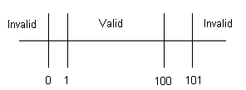

Equivalence class Partitioning
- Equivalence partitioning is a method for deriving test cases
- In this method given input is divided into number of equivalence classes.
- From each equivalence class one input value is chose for testing.
- For each piece of the specification, generate one or more equivalence classes
Label the Classes as “Valid” and Invalid”
- Generate test cases that cover as many possible valid and invalid Equivalence classes
Example:
Consider any edit field which can accept values b/w 18-35.
From the given range of i/p value we can form 3 equivalence classes.
i) Less than 18.
ii) Between 18-35.
iii) Greater than 35.
Take any value from three equivalence classes and test them.
6, 25,100
Ex2:
User Name | Role | Rights
Abhay | Financial Prof. | Assign
Sriram | Customer | View, Add, Update
Ravi | Customer | View, Add, Update
Dinakar | Financial Prof. | Assign
Bhaskar | Employee | View, Delete, Add, Update
Ramya | Financial Prof. | Assign
Pranathi | Financial Prof. | Assign
Harsha | Employee | View, Delete, Add, Update
Suchitra | Agent | View

Identify similar functionalities and divide equally
Divide the inputs, outputs, etc., into areas which are same
Here the assumption is, if one value works then all should work
Identify one from each partition instead of all from one

Role | User Name | Rights
Financial Prof. | Abhay | Assign
Customer | Sriram | View, Add, Update
Employee | Bhaskar | View, Delete, Add, Update
Agent | Suchitra | View

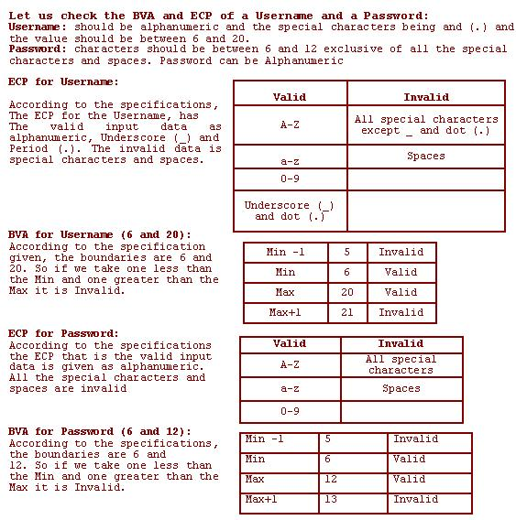
Example:
Customer Name – 2 to 64 Chars
Account Number – 6 digits, first digit is non zero
Loan Amt requested – $500 to $ 9000
Loan Term – 1 to 30 years
Monthly Repayment – Min of $ 10
Customer Name
Conditions | Valid Partitions | Invalid Partitions | Valid Boundaries | Invalid Boundaries
Customer Name | 2 to 64 chars | < 2 Chars  > 64 Chars  Space | 2 Chars  64 Chars | 1 Char  65 Chars

Account Number
Conditions | Valid Partitions | Invalid Partitions | Valid Boundaries | Invalid Boundaries
Account Number | 6 digits &  1st non-zero | < 6 digits  > 6 digits  1st digit = 0  Non-digit | 100000  999999 | 99999  1000000

Loan Amount
Conditions | Valid Partitions | Invalid Partitions | Valid Boundaries | Invalid Boundaries
Loan Amount | 500-9000 | < 500  > 9000  Non-numeric | 500  9000 | 499  9001

Decision Matrices
Business rules & logic portrayed as flow-charts or tables
Rules and associated results are charted in a simple format
Decision tables can make for instant test cases
New comers can glance at decision table and come to know the rules and corresponding actions

Condition | 1 | 2 | 3 | 4 | 5
Valid Card | N | Y | Y | Y | Y
Valid PIN | - | N | N | Y | Y
Invalid PIN | - | N | Y | N | N
Balance OK | - | - | - | N | Y
Action
Reject Card | Y | N | N | N | N
Reenter PIN | N | Y | N | N | N
Keep Card | N | N | Y | N | N
Reenter Request | N | N | N | Y | N
Dispense Cash | N | N | N | N | Y

Error Guessing
Error Guessing is technique which involves making a list of the errors expected to occur in a particular area of the system and then designing a set of test cases to check for these expected errors
It is more an art than science but is very effective if a tester familiar with the history of the system
Cause-Effect analysis (Fish Bone)
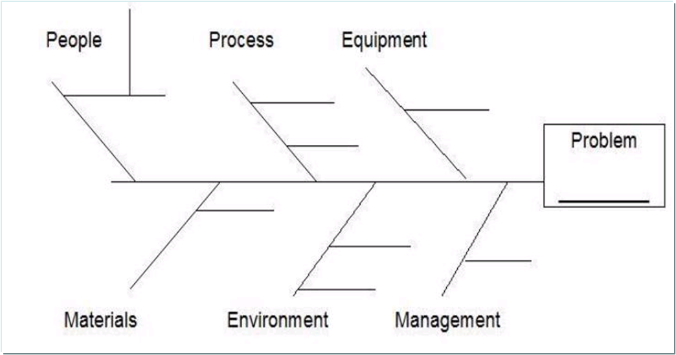

Test Coverage
Tracking and ensuring that the test cases authored cover all the user stories is very essential
Changes in user stories should be tracked and test cases should be updated accordingly
Test Coverage can be tracked using a Requirement Traceability Matrix(TRTM) or a Test Management Tool
Defects arising apart from test suite execution should be converted to test cases to increase the test coverage

Pesticide Paradox
Pesticide Paradox – a test principle says
“Every method you use to prevent or find bugs leaves a residue of subtler bugs against which those methods are ineffectual”
New test cases need to be created, using the different methods already explained to increase coverage and effectiveness

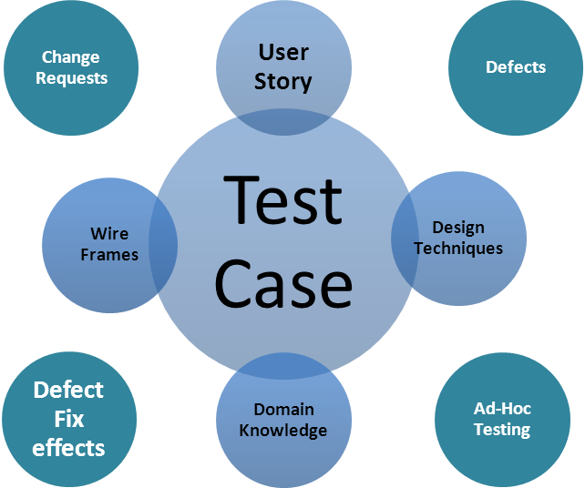

Web Testing
Guidelines for Web testing
Purpose
World Wide Web is browsed by customers with different knowledge levels across the globe and one has to concentrate on various aspects to make effective presentation of website in WWW.
Aspects to cover:
Functionality
Usability
User Interface
Compatibility
Security
Performance
Sever log files

Checking the Functionality
Links
Objective is to check for all the links in the website.
All hyperlinks
All Internal links
All External Links
All mail links
Image links
Forms/Screens
Check for integrity of submission of all forms
All field level checks
All field level validations
Functionality of [submit], [update], [date] & [view]
Handling of wrong inputs
Default values if any (standard)
Optional versus Mandatory fields.

Database
Two types of errors that may occur in web application.
Data Integrity: Missing or wrong data in table.
Output Errors: Errors in writing, editing or reading operation in the table.

Usability Testing
How simple customer can browse the website or user friendliness.
Navigation
Navigation describes the way user navigates with in a web page, between different user interface controls (buttons, check boxes, combo boxes, dropdown lists... etc)
Application navigation is proper through tab (keyword)
Application navigation through mouse.
Main features accessible from the main/home page (mother window)
Any hot keys, control keys to access menus.
Content
Correctness is whether the information is truthful.
The accuracy of the information is whether it is without grammatical or spelling errors.
Remove irrelevant information from your site this may otherwise cause misunderstanding or confusion.
Spelling and grammar
Updated information (contact details mail ID's help reports)
User Interface (GUI) Testing
Verifying the User interface of the application, means how the frontend design, font color, Text format, Labels, background, foreground etc.
This is the process of verifying the look and feel environment of the application.
Every drop down box should have the first choice as NONE (it could be any other meaningful sentence, such as 'choose one 'or ' select'.)
Horizontal scrolling is not preferable in general. Avoid using horizontal scroll bar ensure that the use of vertical scroll bar is Judicious.
Illegal operations should give popup messages (message should be simple and clear)
Positive popup messages should be displayed (submitted, deleted, updated, done, cleared)
Avoid long scrolling drop down list make it short.
Client side Compatibility
Platforms
Check for the website compatibility with
Windows (95, 98, 2000, 2003,NT)
UNIX
LINUX
Macintosh(If applicable)
Browsers
Internet Explorer (7.x, 8.x,9.x, 10.x)
Netscape navigator(3.x, 4.x, 6.x, 7.x)
AOL
Mozilla Firefox 2.x and 3.x
Safari 3.0 (compatible with MAC OS)
Security
See how secure my application is:
Valid and invalid Login
Limits defined for the number of tries
Can it be passed by typing URL to a page inside directly in the browser?
All transactions, error messages, security breach attempts should get logged in log files somewhere on web server for easy traceability.
No access to edit scripts on the server with out authorization.
Performance
Connection Speed:
Try with different connection speeds
Load:
Will there be peak loads and how systems react
Can your site handle a large amount of users requesting a certain page.
Stress:
Stress testing is done in order for actually break a site or certain features to determine how the system reacts.
Stress tests are designed to push and test system limitations and determine whether the system resources gracefully from crashes.
Server Log Files
For every client request to the server, server side client information will be stored in the form of logs automatically.
Logs Contains:
Client Request
Server Response
Time of request
Client IP address

Projects & Technologies

Difference between Project & Product ?

Project :
A software that is developed based on the specific requirements of a Customer is called an Project.

Product:
A Software that is developed based on the overall market requirement is called as a s/w Product.

Initially no customer (Developing company itself) are available for the Product, and later more customers will be added depends on how popular your product is.

Types of Projects
There are three types of projects.
Desktop or Standalone applications
Client and server processing should be on single machine.
Web Application
All Client and server will be different machine, here single data base server is sharable to unlimited no. of clients.(users) via WEB.
Example:-
Banking Application, Insurance Application
Mailing Application, Health care Applications
Social Networking Application, Financial Applications
System Products
Software which makes move to run the hardware components is called system products.
Example:
Device drivers, Operating systems

Software Environment:
Environment is a combination of three layers
- Presentation layer
- Business layer
- DB layer

Types of Environments /Architectures
There are 4 types of environments
- Standalone environment / 1-Tier architecture
- Client Server Environment/2-Tier architecture
- Web Environment /3 –Tier architecture
- Distributed environment/ N-Tier Architecture

1-Tier architecture:
IN 1-Tier architecture all three layers reside in one single machine

2 tier architecture:
In 2 tier architecture the application is split in to two parts which is located in two machines called as client and server that is why it is also known as client server architecture.

3-Tier
In 3 tier architecture the application is physically divided and located in to three different machines.
In this architecture, one takes care only about client related issues known as client tier, second one takes care about all the business logic related issues and input & outputs taken from the client tier known as middle tier and the third contains the database and responsible for managing and manipulating all the database related issues called as database tier so this architecture is basically used for load balancing and fault tolerance.

N-Tier Architecture
It is also called as multi-tire architecture in which the presentation, the application processing, and the data management are logically separate processes.
For example, an application that uses middleware to service data requests between a user and a database employs multi-tier architecture.

Model View Controller Architecture
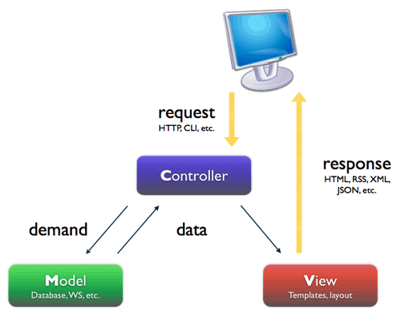
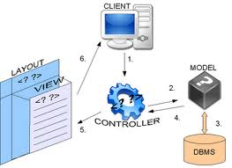

MVC Framework
MVC - Model View Controller
What is MVC
One of the most popular framework or pattern. It’s just like three tire architecture.
This bifurcates our application in three different parts or layers which are Presentation layer, Business Layer and Data Access Layer.
View:
View is our Presentation layer. Means what ever end user see or interact with our application is just View.
The view object refers to the model. It uses the query methods of the model to obtain the contents and renders it.
The view is not dependent on the application logic. It remains same if there is any modification in the business logic.
In other words, we can say that it is the responsibility of the view's to maintain the consistency in its presentation when the model changes.
Controller
Whenever the user sends a request for something then it always go through the controller.
The controller is responsible for intercepting the requests from view and passes it to the model for the appropriate action.
After the action has been taken on the data, the controller is responsible for directing the appropriate view to the user.
In GUIs, the views and the controllers often work very closely together.
Model:
The model object knows about all the data that need to be displayed.
It is model who is aware about all the operations that can be applied to transform that object.
It only represents the data of an application. The model represents enterprise data and the business rules that govern access to and updates of this data.
Model is not aware about the presentation of data and how that data will be displayed to the browser.
Why we use this model?
Re-use of code. It’s single for web and windows we just have to change the views.
Suppose a company wants software of inventory on both windows and web then you don’t need to write whole code 2 times instead of this you have to write 2 views while model and controller will same for both. This is first and most important benefit
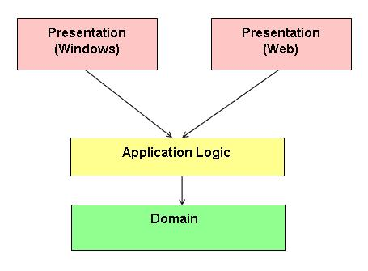
Secondly it gives proper separation between presentation layer, Business layer and Data Layer.

Software Technologies
What is Technology

Java:
It is a SUN Microsystems Product
It is Open Source software and not a licensed one
It is a Platform Independent
It supports Object Oriented Programming concepts
Different types of Java (we have 3 types):
J2SE
J2EE
J2ME

J2Standard Edition
Using J2SE, we can develop any desktop application
Contains the following things in J2SE
Java Standards
AWT (Abstract Window Toolkit)
Swings
Applets

J2EE (Java Platform Enterprise Edition)
Widely recognized as the most versatile and extensible environment for developing and deploying enterprise applications, the J2EE platform consists of a set of services, application programming interfaces (APIs), and protocols that provide the functionality for developing Web-based applications
Contains the following things in J2EE
JDBC JSP Servlets Struts EJB

J2ME (Java Platform Micro Edition)
Java Platform, Micro Edition, or Java ME, is a Java platform designed for embedded systems (mobile devices are one kind of such systems) . Target devices range from industrial controls to mobile phones (especially feature phones) and set-top boxes.
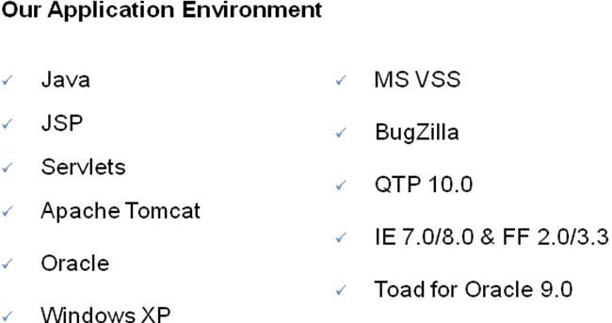
Project Testing

Build from Development to Testing:
Once unit testing is approved, developers will integrate the units and release the build for testing, along with build release note.

Tech lead or development lead will update the build and released note into VSS and he will send an email to test lead saying that build is ready for testing and VSS location of build and he will mentioned build period.

First build release note contains
Requirements implemented in this build (Req#)
URL of the application
Admin user ID and Password
DSN-Data source Name
Database username and Password

Second build Release note contains
Defects fixed in this build (Defect#)
Requirements implemented in the build (Req#)
URL of the application
Admin user ID and password
DSN-Data source Name
Database username and password.

Build Release Management:
In general the development team is maintaining corresponding s/w build in configuration repository of corresponding project.

During test execution, the test engineers are receiving modified s/w build after implementing the new requirements or fixing the defects. Development team will Build & deploy the application on a server before they hand it over to Execution team.

To distinguish old s/w build and modified s/w build, the programmers are assigning version numbers to that builds. Test engineers are identifying old build and new build depending on that version numbers.

For this version controlling the developers are using version control s/w.
[Ex: VSS – visual source safe]

The VSS s/w maintains old programs & modified programs s/w.

Defect Management:-

What is Defect?
In computer technology, a Defect is a coding error in a computer program. It is defined by saying that “A software error is present when the program does not do what its end user reasonably expects it to do.

Who can report a Defect?
Anyone who has involved in software development life cycle and who is using the software can report a Defect. In most of the cases defects are reported by Testing Team.
A short list of people expected to report bugs:
Testers / QA Engineers
Developers
Technical Support
End Users
Sales and Marketing Engineers

Defect/Bug/Error/Issue/Failure:
Any flow or imperfection in a software work product
Expected results is not matching with the application actual Result.
Any variation from the requirements

Difference between Defect\Error\Failure:
Defects which is identified on tester machine. ie called Defect or Bug
The same problem which is identified on developer machine is called Error
The deviation from the specified or expected behavior that is visible to end users is called a FAILURE.
Defect and Bug differentiation: Tester reports a defect & when Dev team accepts then, it’s a bug.

Defect/Bug Life Cycle:

- Identify the Defect (Re-collect the exact step for defect fing)
- Reproduce the Defect
- Report the Defect
- Bug fixing
- Bug Resolving
- Bug Closing thru Regression

Major Activities in Defect Management:

- Defect Identification
- Defect Reporting
- Defect Tracking
- Defect closing

Defect Identification:
While executing the test cases, expected Result is not matching with actual result.
Application is not working as per customer FRS we will report it as a defect.

How you ensure that a product is a Quality one?
- Identify a Defect.
- Isolate the defect
- Allow defect to get rectified
- Ensure that the defect is not present & has not created a new defect in new build/QA Cycle.

Defect Status Life Cycle:

Defect life cycle or bug life cycle comprises of all the defect status changes it would under go once a new defect is logged and till the defect is closed or cancelled.
Defect Life Cycle indicates the flow on how defects are being analyzed, assigned, fixed, verified and closed or cancelled.
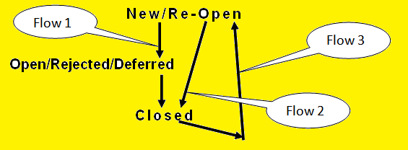
Description of each defect status:
New – When a Defect is logged and yet to be assigned to a developer. Usually Project Manager or Dev Lead will decide on which defects to be assigned to which developer.

Assigned – indicates that the developer who would fix the defect has been identified and has started analyzing and working on the defect fix.

Duplicate – Manager or Developer will update the status of a defect as “Duplicate” if this defect was already reported.

Rejected / Not Reproducible – This status indicates that the developer is not considering the defect as valid due to following reasons
a) Not able to reproduce
b) Not a valid defect and it is as per requirement
c) Test Data used was invalid
d) Defect referring to the Requirement has been de-scoped from the current release, tester was not aware of these late changes.

Deferred – Defect fix has been held back because of time or budget constraints and project team has got approval from customer to defer the defect till next or future release.

Fixed – Developer has fixed the defect and has unit tested the fix. The code changes are deployed in test environment for verifying the defect fix.

Reopen –
Status is changed to “Reopen” by a tester, when a tester finds the defect is Not fixed or partially fixed.
Developer who fixed the defect looks into the comment that was provided by the tester at the time of reopening the defect.
Developer will change the status to “Assigned” and starts working on the fix again.
Incase the developer wants the tester to re-verify the defect then he/she will add a comment and will change the defect status to “Fixed”.

Closed – Tester verifies the defects that are in “Fixed” status and once they find the defect is fixed, they change the status to “Closed”. This is the last status of Defect Life Cycle.

Cancelled – This status indicates that the tester realized that the defect logged by him was invalid and agreed to cancel it.

Types of Defects and Defect Standard Resolution types are missing

Defect Resolution types:

- Duplicate
- Function as defined
- Not Applicable
- User Misunderstanding
- Enhancement
- Need More Information
- S/w Limitation
- H/w Limitation
- Fixed
- Fixed Indirectly
- No plan to fix
- Not Reproducible

Defect Report Template:
Defect Name/id:
Release name:
Project name:
Module name:
Status:
Severity:
Priority:
Test case id name/name:
Brief description:
Detail description:
Following are the steps to reproduce the defects
1.
2.
3.
Expect result:
Actual result:

Contents of Defect Report:
Defect id/name:
Describes the name of the defect according to the company standard.
The naming convention varies from company to company.
E.g. cbo_hr_def_001
Release name:
Describes the name of the release.
E.g.Release_1, Release_2, Release_3

Project name:
Describes the name of the project.
E.g. Citibank online.
Module name:
Describes the name of the module.
E.g. Sales.
Status:
Describes the status of the bug
E.g. New/ Open, Fixed, Closed,Re-open.
Severity:
Describes the impact of defect on the business
E.g. Blocker/critical/major/minor
Priority:
Describes the priority or urgency of fixing the defect.
E.g. P1/P2/P3/P4
Test case id/Name:
Describes the name of the test case according to the company standard.
E.g. cbo_finance_001
Environment:
Describes the environment of where the defect was found like operating system and browser name.
E.g. Win Xp, IE 6.0
Test case type:
Describes the type of the test case
E.g. Smoke/functionality/non-functionality test case’s
Detailed description:
Describes the steps on how the defect was detected.
Expected result:
Describes the expected result based on client requirements.
Actual result:
Describes the actual result after the test condition was executed.

What is Severity and Priority?
What is severity?
Severity defines the importance of defect with respect to functional point of view …

Responsibility of “Testing Team”.

Classification could be
Blocker
CRITICAL
MAJOR
Minor

Blocker: - A major functionality is failed. Testing can not continue
Critical : - A major issue in functionality or system component is not working properly, and testing can continue.
Major: - A minor issue that imposes some loss of functionality, testing can proceed without interruption.
Minor: - Usability and user Interface issues.

What is PRIORITY:-
Priority defines the importance of defect with respect to client point of view... Means how soon it should fix.
Responsibility of developing team [Development Lead (Tech lead)]
Classification could be
P1 – Blocker – Drop whatever else you reworking on and fix this now
P2 – Critical
P3 – Major
P4 – Minor

Defect Severity VS Defect Priority
The General rule for the fixing the defects will depend on the Severity. All the High Severity Defects should be fixed first.
This may not be the same in all cases sometimes even though severity of the bug is high it may not be taken as the High priority.
At the same time the low severity bug may be considered as high priority.

Defect Tracking Sheet
Defect No | Description | Origin | Severity | Priority | Status
Unique No | Dec of Bug | Birth place of the Bug | Blocker  Critical  Major  Minor | P1  P2  P3  P4 | Submitted  Accepted  Fixed  Rejected  Postponed  Closed

Defect Tracking Tools
Bug Tracker – Quality Center
BugZilla
BugTracker
Track+
Mantish

Daily Status Report: Every day evening by 5.30pm we will send the Daily Status report to our Test Lead in the Email, about the status of the assigned tasks.
For Ex:
Rajesh,
I Have Completed the 30% of Assigned Task. In that Prepared 100 Testcases.

Thanks & Regards,
**********************.
Daily Defect Report: Every day evening by 5.30pm, if we found any defects we will send the Daily Defect report to test lead using Daily Defect report template.
Ex:
Rajesh,
Today, I have Executed 70 Testcase. In that % Testcase are Failed and Reported as Defects. Please find the Daily Defect Report as an Attachment.

Regards,
**********.

Daily Defect Report Template:
S.No | Defect ID | Defect Title | Severity | Tester | Logged Date
01 | 123 | IBS-1.0v-B01-Mahesh-Aboutus-contacts Function is not Working | Major | Mahesh | 25/11/2010
02 | 127 | IBS-1.0v-B01-Mahesh-Homepage-[Reset] Function is not Working. | Moderate | Mahesh | 25/11/2010
03 | 130 | IBS-1.0v-B01-Mahesh-Admin-Inconsistency is Observed While Adding Agent. | Major | Mahesh | 25/11/2010

Weekly Status Report: Every week ending Friday by 5.00pm we will send the weekly status report to Test lead using status Report template.
Ex: Rajesh,
Please Find the Weekly Status Report as an Attachment.

Regards,
**********.
Weekly Status Report Template:
Project Code |  | Week Ending
Project name |  | Tester

High Level Summary.
Major Accomplishments Since Last Reporting Period.
Items not Completed as Planned.
Defects Summary-by Severity.
S.No | Defect ID | Severity

Effort Summary.
S.No | Activity | Planned Hours | Used Date
Risks and Issues. Items Planned for next Reporting Period.
Retesting Report:
If Test Lead will Assign the Fixed Defects for Retesting, Test Engineers will Perform the Retesting on all Fixed Defects Against new Build and They will Update Status in Bugzilla and as well as Retesting Template and They will Forward same to Test Lead.
Retesting Template:
S.No | Defect ID | Defect Title | Severity | Commited Release | Fixed in Build | Tester | Status Before Test | Status After Test | Comments
01 | 123 | IBS-1.0v-B01-Mahesh-AboutUs-“Contacts”Link is not Working | Major | 2.0 | 01 | Mahesh | Fixed | Fix Verified
02 | 129 | IBS-1.0v-B01-Mahesh-Admin-unable to Update Agent | Major | 2.0 | 01 | Mahesh | Fixed | Fix Verified | Defect is Still Exists.
03 | 133 | IBS-1.0v-B01-Mahesh-Admin-Unable to add Agent | Major | 2.0 | 01 | Mahesh | Fixed | Fix Verified | Unable to Test, Because “Add Agent” is not Working, Reported as a new Defect.

Defect Clasifications or Categories:

- UI Defects
- Boundary Defects
- Calculation Defects
- Compatibility Defects
- Browser Compatibility
- OS Version Compatibility
- OS Upgardation Compatibility
- Configuration Defects
- Hardware Failure Defects
- Load Defects
- Control Flow Defects

Defects in Java Web Application:
List of Defects:
Blank Page is Displayed.
Images are not Loading.
Spelling Mistakes and Alignments.
Invalid PopUp Messages.
Links are not Working.
Getting “Error On Page” on Status Bar of The Browser.
Java.lang.Exception.
Java.sql.SQL Exception.
Java.lang.Index Out of Bounds Exceptions.
HTML Code is Displayed on Application.
CODE is Displayed on Application.
Mandatory fields are not Displayed in RED Color.
Data Truncation.
Unable to view the Data from Database.
Able to add the Duplicate names When Field is Declared as Primary Key.
Remembering the Previous added values when trying to add New Group.
Getting the JavaScript Errors in Application.
Java.lang.Number Format Exception.
Java.lang.reflect.Invocation Targe Exception.
Displayed NULL Information in Application.
While adding the Invalid / Duplicate Values, Screens is not Waiting to Enter Valid data, Where as it is Going to Main Page.
While Working on Application, Getting Session Expired-RC1 end.
Defect High priority(P1) and high Severity(Critical).
Java.lang.Exception ; java.lang.Out Of Memory Error;
Defect – high priority(P1) and High Severity(Critical)
The Server Encountered an Internal Error or Misconfiguration and was Unable to Complete Your Request.
Please Contact the Server Administrator you@your.addins andInform them of the Time and Anything you Might have don’t that may have Caused the Error.
More Information About this Error is Available in the Server ERROR log.

Testing Process
Current Project Testing Process:
My Current Project Testing Process Started From Preparation of the Test Plan. My Test Lead is prepared the Test Plan for My Current Project. We are executing the Test Plan, Which Includes, Identifying the Test Scenarios, Review and Approval of the Test Scenarios. Once Test Scenarios are Approved, Preparing the Test Case for all Identified Test Scenarios.
Review and Approved of the Test Case, Executing the Test Case, Performing all Testing Activities Like Re-Testing, Regression Testing and Functionality Testing and Usability Testing + Project Work Flow.

***************************ALL THE BEST**********************************

